Activity: An Inventory of My Traits
Adapted from Genetic Science Learning Center

Objectives:
- Learn a number of easily observable genetic traits.
- Compare individual traits with other students in the class.
- Discover that some traits are more common in a population than others.
- Construct/analyze a table/bar graph summarizing class data.

Traits are observable characteristics that are passed down from parent to child. Inherited traits do not come from aunts, uncles, cousins, and siblings. Traits can only be inherited from parents. An individual will have many traits they share in common with others. In fact, about 99.8% of your genetic information is the same as your six billion or so fellow humans on Earth. It is the final 0.2% that makes you special. Some traits are more common in a population than others.

A widespread misconception is that traits due to dominant alleles are the most common in the population. While this is sometimes true, it is not always the case. For example, the allele for Huntington’s disease is dominant, while the allele for not developing this disorder is recessive. At most, only 1 in 20,000 people will get Huntington’s; most people have two recessive, normal alleles. While a few traits are due to only one gene (and its alleles), most human genetic traits are the product of interactions between several genes.

The traits listed below have commonly been presented as being determined by single genes; however, several have been shown to involve more than one gene, and research studies do not agree on the inheritance patterns of others.

Earlobe Attachment
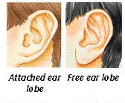
If earlobes hang free, they are detached. If they attach directly to the side of the head, they are attached earlobes.

Some scientists have reported that this trait is due to a single gene for which unattached earlobes are dominant and attached earlobes are recessive. Other scientists have reported that this trait is probably due to several genes. The size and appearance of the lobes are also inherited traits.

Tongue Rolling
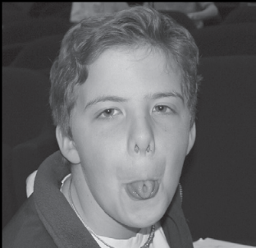
In 1940, the famous geneticist Alfred Sturtevant noted that about 70% of people of European ancestry are able to roll up the lateral edges of the tongue, while the remaining 30% were unable to do so.

Tongue rolling ability may be due to a single gene with the ability to roll the tongue a dominant trait and the lack of tongue rolling ability a recessive trait. However, there is some question about the inheritance of tongue rolling. Recent studies have shown that around 30% of identical twins do not share the trait.
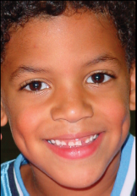

Dimples
Dimples are reportedly due to a single gene with dimples dominant (people may exhibit a dimple on only one side of the face) and a lack of dimples recessive.

Freckles
This trait is reportedly due to a single gene; the presence of freckles is dominant, the absence of freckles is recessive.

Naturally Curly Hair
Early geneticists reported that curly hair was dominant and straight hair was recessive. More recent scientists believe that more than one gene may be involved.

Hand Clasping
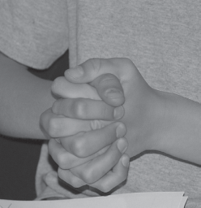
Fold your hands together by interlocking your fingers without thinking about it. Which thumb is on top – your left or your right? One study found that 55% of people place their left thumb on top, 45% place their right thumb on top and 1% has no preference.

A study of identical twins concluded that hand clasping has at least some genetic component. However, other scientists have not found evidence that genetics plays a significant role in determining this trait.

Hairline Shape
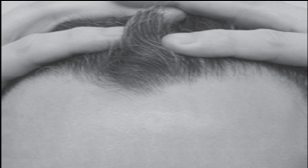
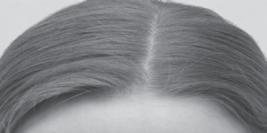
Hairline shape is reportedly due to a single gene with a widow’s peak dominant and a straight hairline

Thumb Extensibility
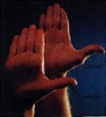
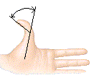
Try to bend your thumbs backwards at the joints. Some people can form at least a 45 degree angle, which is called a hitchhiker’s thumb. Other people have straight thumbs which do not bend in this way.

The thumb extension trait is reportedly due to a single gene. Straight thumb is dominant, with 75% of the U.S. Caucasian population displaying this trait. Only 25% of the population has the recessive hitchhiker’s thumb.

A complicating factor of hitchhiker’s thumb is that about one person in twenty carries the recessive allele and will not express the characteristic despite having the hh genotype.

Colorblindness
Colorblindness is due to a recessive allele located on the X chromosome. Women have two X chromosomes, one of which usually carries the allele for normal color vision; therefore, few women are colorblind. Men only have one X chromosome, so if they carry the allele for colorblindness, they will exhibit this trait. Thus, colorblindness is seen more frequently in men than in women.

PTC Tasting
For some people the chemical phenylthiocarbamide (PTC) tastes very bitter. For others, it is tasteless.
The ability to taste PTC shows dominant inheritance and is controlled by a gene on chromosomes 7. This gene codes for part of the bitter taste receptor in tongue cells. One of its five alleles (forms) causes a lack of ability to sense bitter tastes; the other four alleles produce intermediate to fully sensitive taste abilities. Approximately 75% of people can taste PTC while the remaining 25% cannot.

PTC-like chemicals are found in the Brassica family of vegetables, such as cabbage, brussels sprouts, and broccoli. People who can taste PTC often do not enjoy eating these vegetables, since they taste bitter to them. Non-tasters tend not to notice bitter tastes and therefore may be more likely to become addicted to nicotine (which is bitter).

Blue-gray Eye Color
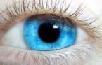
Eye color is the product of the action of several genes. If your eyes are some color other than blue-gray, your eye color is due to pigments deposited at the front of the iris (the colored portion of your eye). People with blue-gray eyes have little or no pigment deposited on the surface of the iris. The presence of blue-gray eyes indicates that an individual is homozygous recessive for that trait. Any other eye color is dominant to blue-gray. (Although brown eye color usually behaves as if dominant to blue eye color, it is possible for two blue-eyed parents to have brown-eyed children.

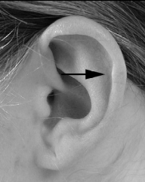
Darwin’s Tubercle

The presence of a bump on the superior portion of the external ear flap is a dominant trait. It may be present on one or both ears. A smooth ear is a recessive trait.

Longer second toe
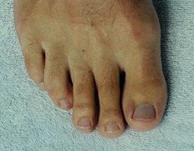
Compare the height of your second toe to your big toe. A longer second toe is a dominant trait and a shorter second toe is recessive trait.

Crossing Legs
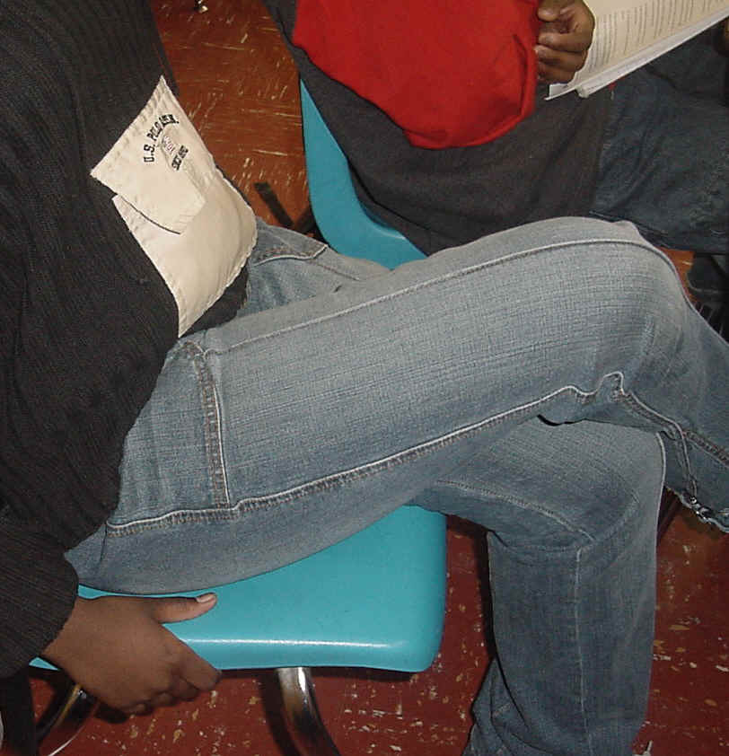
Without thinking, cross your legs. Which leg is on top – your left or your right? Right over left is a dominant trait and left over right is recessive trait.

Inventory of Traits (Self) Data Chart
Trait | D/R | Answer to Trait |  | Dominant (D) or Recessive (R)
Gender |  | Female | Male
Attached Earlobe |  | Yes | No
Tongue Roller |  | Yes | No
Dimples |  | Yes | No
Freckles |  | Yes | No
Curly Hair |  | Yes | No
Hand Clasping (Right over Left) |  | Yes | No
Widow’s Peak |  | Yes | No
Hitchhiker’s Thumb |  | Yes | No
Color Blind |  | Yes | No
PTC Tasting |  | Yes | No
Blue/Gray Eyes |  | Yes | No
Darwin’s Tubercle |  | Yes | No
Longer Second Toe |  | Yes | No
Crossing Legs (Right over Left) |  | Yes | No

Inventory of Traits (CLASS) Data Chart
Number of Students Participating in Survey __________
Trait |  | # | Ratio | % |  | # | Ratio | % | (D) or (R)
Gender | F |  |  |  | M
Attached Earlobe | Yes |  |  |  | No
Tongue Roller | Yes |  |  |  | No
Dimples | Yes |  |  |  | No
Freckles | Yes |  |  |  | No
Curly Hair | Yes |  |  |  | No
Allergies | Yes |  |  |  | No
Hand Clasping (Right over Left) | Yes |  |  |  | No
Color Blind | Yes |  |  |  | No
Widow’s Peak | Yes |  |  |  | No
PTC Tasting | Yes |  |  |  | No
Hitchhiker’s Thumb | Yes |  |  |  | No
Blue/Gray Eyes | Yes |  |  |  | No
Darwin’s Tubercle | Yes |  |  |  | No
Longer Second Toe | Yes |  |  |  | No
Crossing Legs (Right over Left) | Yes |  |  |  | No

Math Hint:
- Write the ratio as a fraction. The ratio is the number of students with the trait compared to the total number of participants.
- To calculate the percentage…
  - Use the ratio and divide the number # of students with the trait by the number of participants in the class. (This will give you a decimal number).
  - To convert to a percentage, multiply the decimal number by 100. (Percent means out of 100)
    - Example: 15 tongue rollers / 21 students in the class x 100 = 71%

Questions:
- Compare the frequency of the trait tongue rolling in the classroom population with the frequency of the general population.*

Trait | Preference | Frequency (%) in  General Population* | Frequency (%) in Class
Tongue  Rolling | Can roll tongue | 70
Tongue  Rolling | Cannot roll tongue | 30

Similarities:

- _________________________________________________________________________________

- _________________________________________________________________________

Differences:

- _________________________________________________________________________________

- _________________________________________________________________________

- A widespread misconception is that traits due to dominant alleles are always the most common in the population. Looking at the class data, does the data collected support this? Support your answer with data.

____________________________________________________________________________

____________________________________________________________________________

____________________________________________________________________________

- People comment that “Joe” looks so much like his uncle. Did Joe inherit his good looks from his uncle? Explain.

____________________________________________________________________________

____________________________________________________________________________

____________________________________________________________________________

- Using graph paper, create a double bar graph using the percentages of any four traits from the class data chart. Use a color key to differentiate between “yes” and “no.” Computer graph: +2 extra crepdit

