[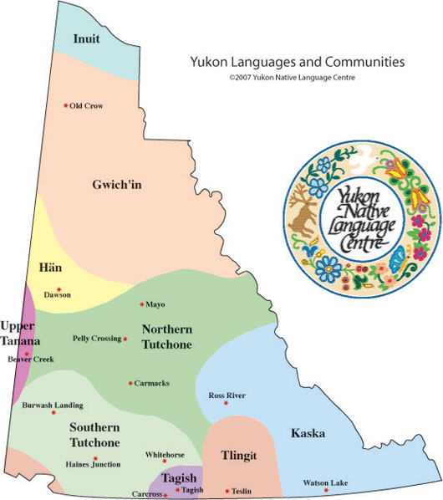](https://www.google.com/url?sa=i&rct=j&q=&esrc=s&source=images&cd=&ved=2ahUKEwi6q5_UrNriAhVHnOAKHR1PC1QQjRx6BAgBEAU&url=%2Furl%3Fsa%3Di%26rct%3Dj%26q%3D%26esrc%3Ds%26source%3Dimages%26cd%3D%26ved%3D%26url%3Dhttps%253A%252F%252Fwww.sgsyukon.ca%252Flanguage-initiatives%252Fyukon-first-nations-languages%252F%26psig%3DAOvVaw1d7tQUEhPdbFY9mN4HrpkT%26ust%3D1560099203885733&psig=AOvVaw1d7tQUEhPdbFY9mN4HrpkT&ust=1560099203885733)

