[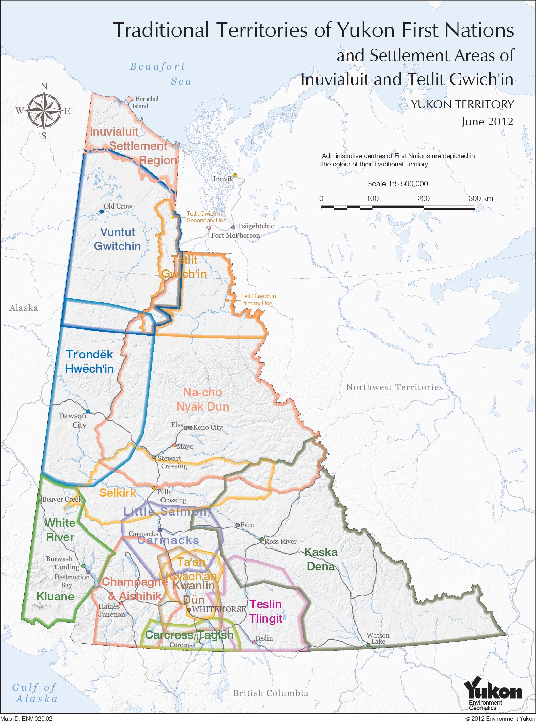](http://nextgenerationhydro.ca/files/uploads/2014/12/03_Traditional_Territories_ENV.020.02.jpg)