Part B- Phoebe
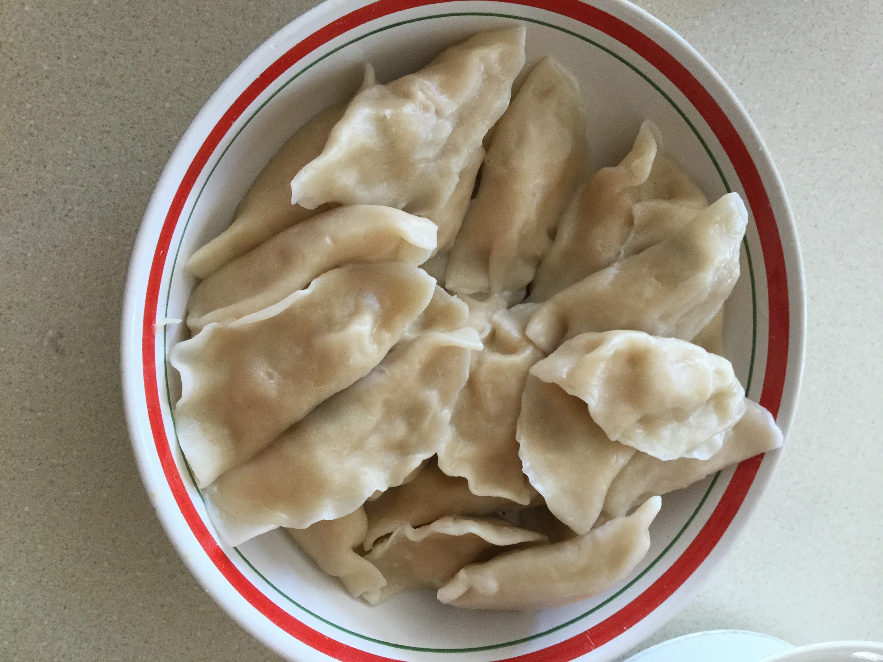
Chinese Pork Dumplings Ingredients needed:- ½ cup soy sauce
-1 tablespoon seasoned rice vinegar
-1 tablespoon finely chopped Chinese chives
-1 tablespoon sesame seeds
-1 teaspoon chile-garlic sauce (such as Sriracha®)
-1 pound of ground pork
-3 cloves garlic, minced
-1 egg, beaten
-2 tablespoons finely chopped Chinese chives
-2 tablespoons soy sauce
-1 ½ tablespoons sesame oil
-1 tablespoon minced fresh ginger
-50 dumpling wrappers
-1 cup of vegetable oil for frying
-1 quart water, or more as needed
Instructions: 1. Combine 1/2 cup soy sauce, rice vinegar, 1 tablespoon chives, sesame seeds, and chile sauce in a small bowl. Set aside.
2. Mix pork, garlic, egg, 2 tablespoons chives, soy sauce, sesame oil, and ginger in a large bowl until thoroughly combined. Place a dumpling wrapper on a lightly floured work surface and spoon about 1 tablespoon of the filling in the middle. Wet the edge with a little water and crimp together forming small pleats to seal the dumpling. Repeat with remaining dumpling wrappers and filling.
3. Heat 1 to 2 tablespoons vegetable oil in a large skillet over medium-high heat. Place 8 to 10 dumplings in the pan and cook until browned, about 2 minutes per side. Pour in 1 cup of water, cover and cook until the dumplings are tender and the pork is cooked through, about 5 minutes. Repeat for remaining dumplings. Serve with soy sauce mixture for dipping. Second photo above is when the dumplings are cooked.
Family feedback: Nice flavour of the pork. Dip some soy sauce to add more flavour. Slightly bland.
Personal feedback: I would definitely make dumplings with this recipe again. Might add more soy sauce into pork mixture.

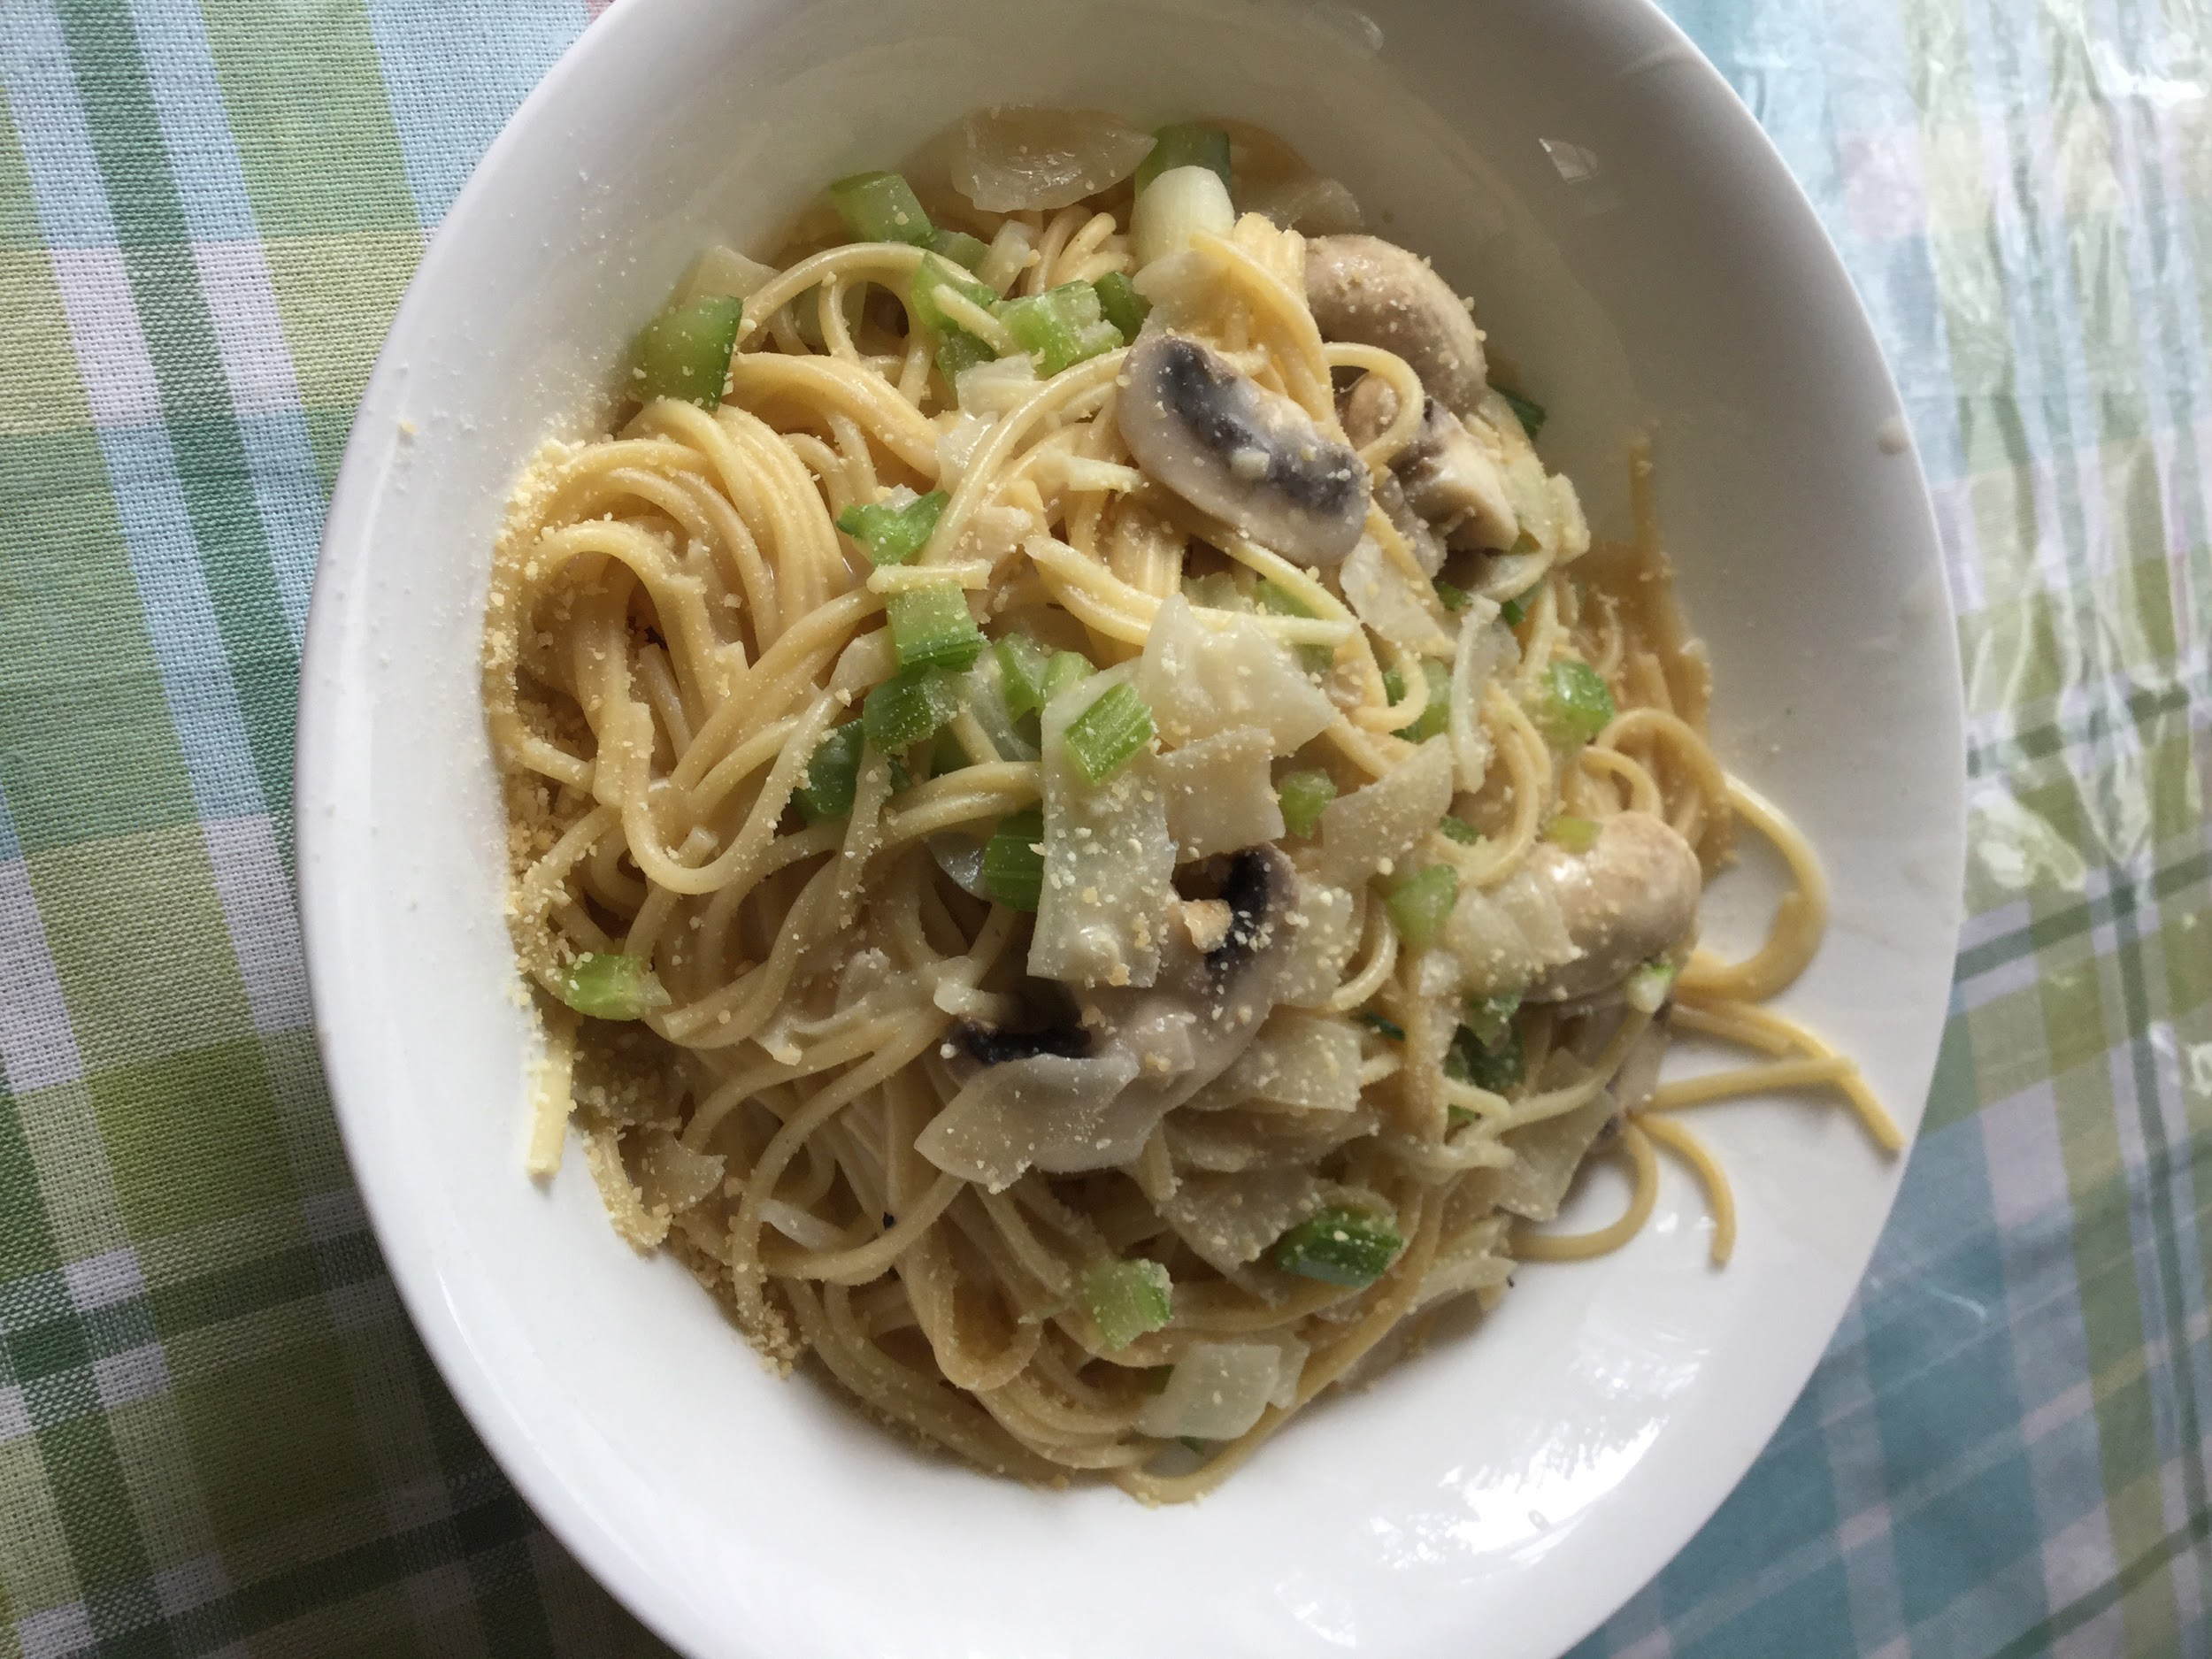
Creamy Mushroom Pasta
Ingredients needed:-160g/ 6oz fettuccine or linguine
-2 tbsp (30g) unsalted butter
-1/2 tbsp olive oil
-300g/ 10 oz mushrooms , sliced 1/3 cm / 1/8" thick (white, cremini/swiss brown)
- 2 garlic cloves, finely chopped
-1/2 cup (125ml) chicken broth/stock , low sodium (or veg)
-3/4 cup (185ml) cream , heavy / thickened
-1/3 cup (30g) parmesan , finely grated (extra parmesan for serving-optional)
-1/2 tsp salt and pepper , each
Instructions: 1. Cook pasta in salted water for 1 minute less than time per packet (start this mid mushroom cook). Just before draining, scoop out 1 cup cooking water, then drain.
2. Melt butter and heat oil in a large skillet over high heat.
3. Add mushrooms and cook, stirring regularly. When they start to sweat, add a pinch of salt and pepper.
4.When pretty golden (about 4 - 5 minutes), add garlic and cook until garlic is golden and mushroom is golden. I also added celery bits as well.
5. Stand back and add wine (it will be steamy), stir, scraping the bottom of the skillet. Simmer rapidly until the wine has mostly evaporated and the winey smell is gone.
6. Add broth, cream, parmesan, salt and pepper. Stir to dissolve parmesan and simmer for 2 minutes, stirring regularly.
7. Transfer pasta into sauce, toss for 1 - 2 minutes until sauce thickens and coats pasta. If sauce gets too thick (rather than slick, see video), add a splash of reserved pasta cooking water.
8. Serve immediately with extra parmesan!
Family feedback: Nice combo! Personally, don’t add the olive oil, don't mix with the cheese/parmesan.
Personal feedback: Don’t add olive oil, or maybe just a little bit. It ruins the cheese flavor slightly.
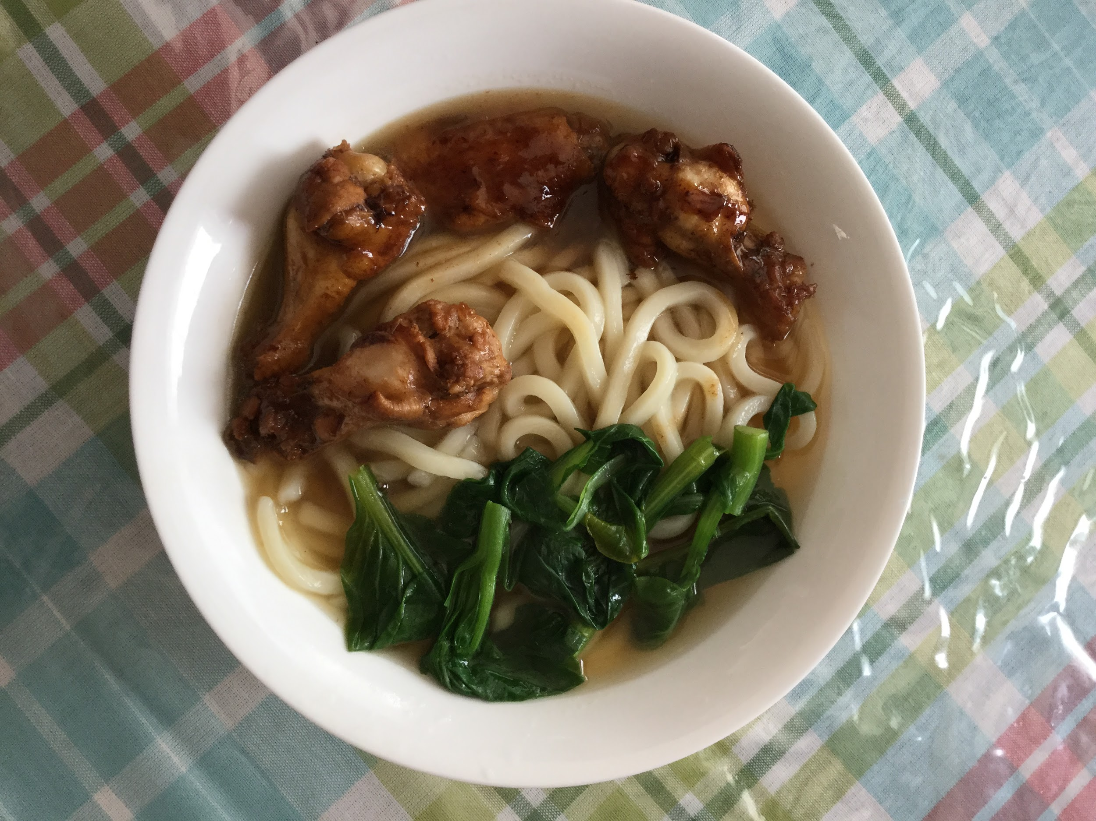
Udon Noodle Soup:
Ingredients needed:-8 ounces of uncooked udon noodles
-2 (14 1/2 ounce) cans of low sodium beef broth
-3 tablespoons of low sodium of soy sauce
- 3⁄4 cup diagonally cut green onion
-2-3 slices of yu choy
-2-4 chicken legs/wings
Instructions: 1. Cook noodles per package directions; drain.
2. Add garlic, and broth to a large saucepan; bring to a boil.
3. Lower heat, and simmer for 10 minutes.
4. Combine soy sauce, in a small bowl; stir with a whisk.
5. Heat a large nonstick skillet coated with cooking spray over med-high heat.
6. Add in yu choy, stir/saute 2 minutes.
7. Stir in soy sauce mixture; cook for 2 minutes stirring constantly.
8. Add vegetable mixture to broth mixture; stir in beef.
9. Cook for 2 minutes or until chicken legs/wings lose their pink color.
10. Stir in noodles, green onions
Family feedback: I love the chicken legs/ wings with the udon. It adds great flavour to the meal!
Personal feedback: Overall, I like the way it turned out using this recipe. I would definitely make this meal again!
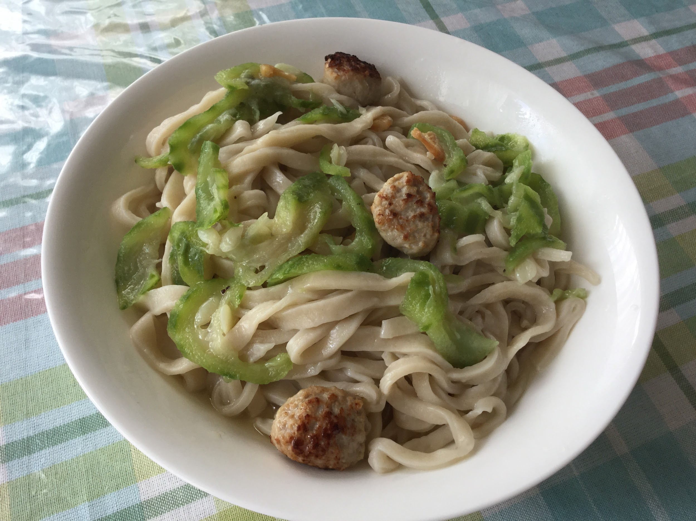 Easy Handmade Noodles Ingredients needed:- 400 grams (2 2/3 cup) all-purpose flour, and extra to dust the working surface -½ tsp of salt
-1 cup 3 tbsp (280ml) of water (room temperature)
Instructions: To prepare the dough: 1. Combine flour and salt in a large bowl and mix well. Slowly blend in water and mix with a pair of chopsticks, until water is integrated with the flour and there is no dry flour left. Dust both hands with dry flour, then start to knead by hand until dough forms. The dough should be quite soft and sticky.
2. Dust a working surface with dry flour. Transfer the dough onto it and continue to knead until the surface turns smooth and the texture springy, 10 to 15 minutes. Dust hands and the working surface with extra flour whenever the dough starts to feel sticky during the process.
3. Alternatively you can use a stand mixer to make the dough. Attach the dough hook to the mixer, transfer the flour and the water into the bowl, and turn on low speed. Stop the mixer and scrape the flour from the bowl if needed. Mix until the dough becomes smooth and elastic, about 15 minutes.
4. Dust a large bowl with dry flour. Transfer the dough to that bowl and cover the dough with a damp dish towel. Cover the bowl with a lid (or plastic wrap). Let the dough rest at room temperature for at least 2 hours (or store the dough in the fridge if you're planning to use it the next day, after resting at room temperature).
5. Dust the working surface and both hands with flour. Transfer the dough onto the working surface and knead it a few times. Divide the dough into 2 equal pieces, then again to make 4 pieces total. Knead each piece of dough by hand to shape a ball.
6. Dust the working surface again. Take one piece of dough and press it into a round disc. Roll it with a rolling pin into a long and round sheet, about 0.2 inches thick. Roll out the rest of the dough pieces the same way. Use large bowls or plastic wrap to cover and seal the dough sheets, to keep them from drying out. Let rest for another 30 minutes to 1 hour.
To pull and cook noodles: 1. Right before making noodles, bring a medium sized pot of water to a roaring boil (very important).
2. Work on the dough sheets one by one. You should cover the rest of the dough with a damp dish towel or plastic wrap.
3. Slice the dough sheet into several strips, about 2 centimeters (0.8 inches) wide (or narrower if you want thinner noodles).
4. Pick up a strip of dough and start to pull it from one end to shape an evenly thick, long noodle, until it becomes quite thin and almost breaks apart. It’s fine if the noodle breaks into 2 to 3 shorter segments. Drop the noodles immediately into the boiling water.
5. Pull another 2 to 3 strips of dough and drop them into the boiling water. Cover the rest of the dough with a damp dish towel. Boil the noodles until cooked through,1 to 2 minutes.Transfer to a plate and set aside. Work on the rest of the dough in the same manner.
To serve and store: 1. You can use the noodles in any noodle soup or mix them with sauce. If you aren’t going to serve the noodles immediately, add a few drops of sesame oil onto them and mix by hand. You should always eat the noodles while they’re warm and fresh, because they will become sticky and turn into a solid mass once they cool off. Once noodles are finished, you can cook your veggies (bitter melon) and meat. Once cooked, add onto the handmade noodles.
2. Store leftover noodles in an airtight container in the fridge for 1-2 days.
3. To serve leftover noodles, place them in a colander so that you can easily dip them into a pot of boiling water. When you do this, use a pair of chopsticks to gently separate the noodles, and leave them in the water until warm. Heating them this way shouldn’t take more than 30 seconds.
Family feedback: Noodles incorporated with meat and veggies nicely! Some pieces are thinner than others, which doesn't really matter. Somewhat bland.
Personal feedback: Next time, I would add some more salt than the recipe has recommended, perhaps adding a tiny bit of soy sauce for some more flavour.
Dinner
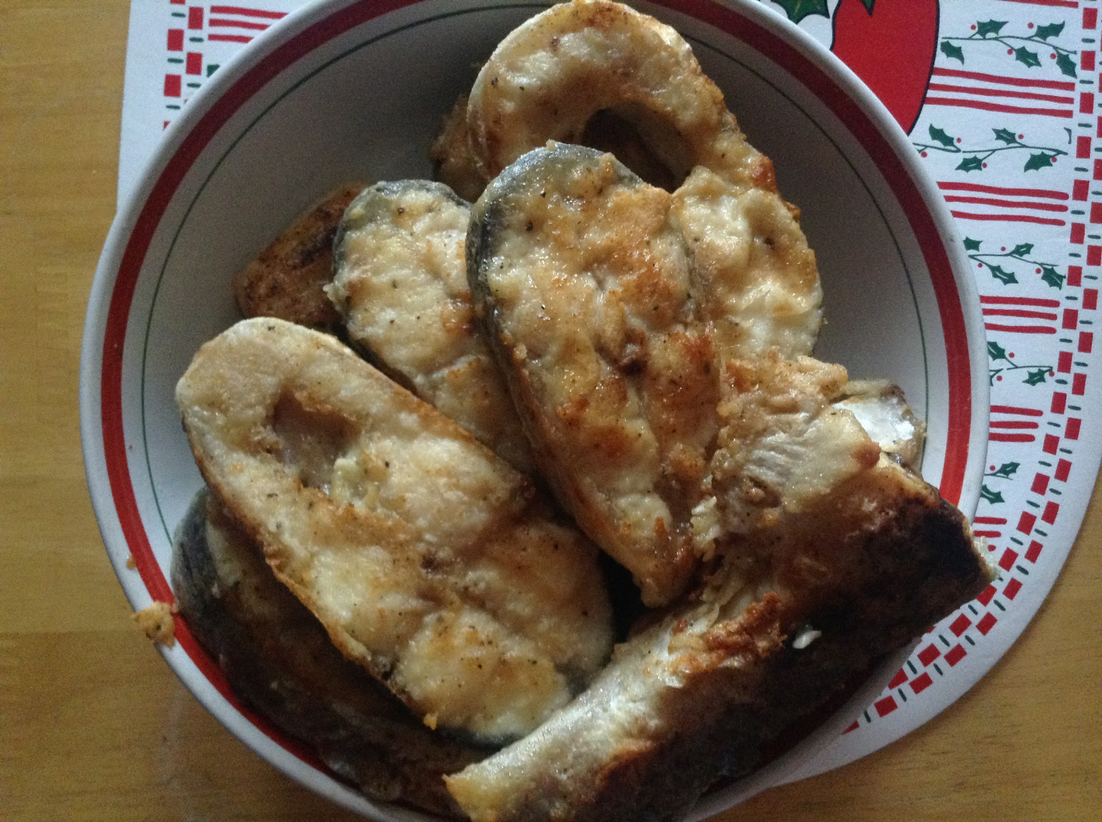
Salmon Steak
Ingredients needed: -4 (12-oz) salmon steaks (bones removed)
-Kosher salt
-Freshly ground black pepper
-2 tbsp. extra-virgin olive oil
-2 tbsp of butter
-2 cloves garlic, minced
-Juice of 1 lemon
-2 tbsp. honey
Instructions: 1. Season salmon on both sides with salt and pepper. In a large skillet over medium-high heat, heat oil and butter. Add salmon and cook until bottom is golden, 5 minutes, then flip. Add garlic, lemon juice, honey, and red pepper flakes. Cook until salmon is cooked through, another 5 minutes, spooning sauce over salmon as it cooks.
Family feedback: Just a little salty, a bit greasy.
Personal feedback: Add a smaller proportion of salt to the salmon and cut down on the oil as well.

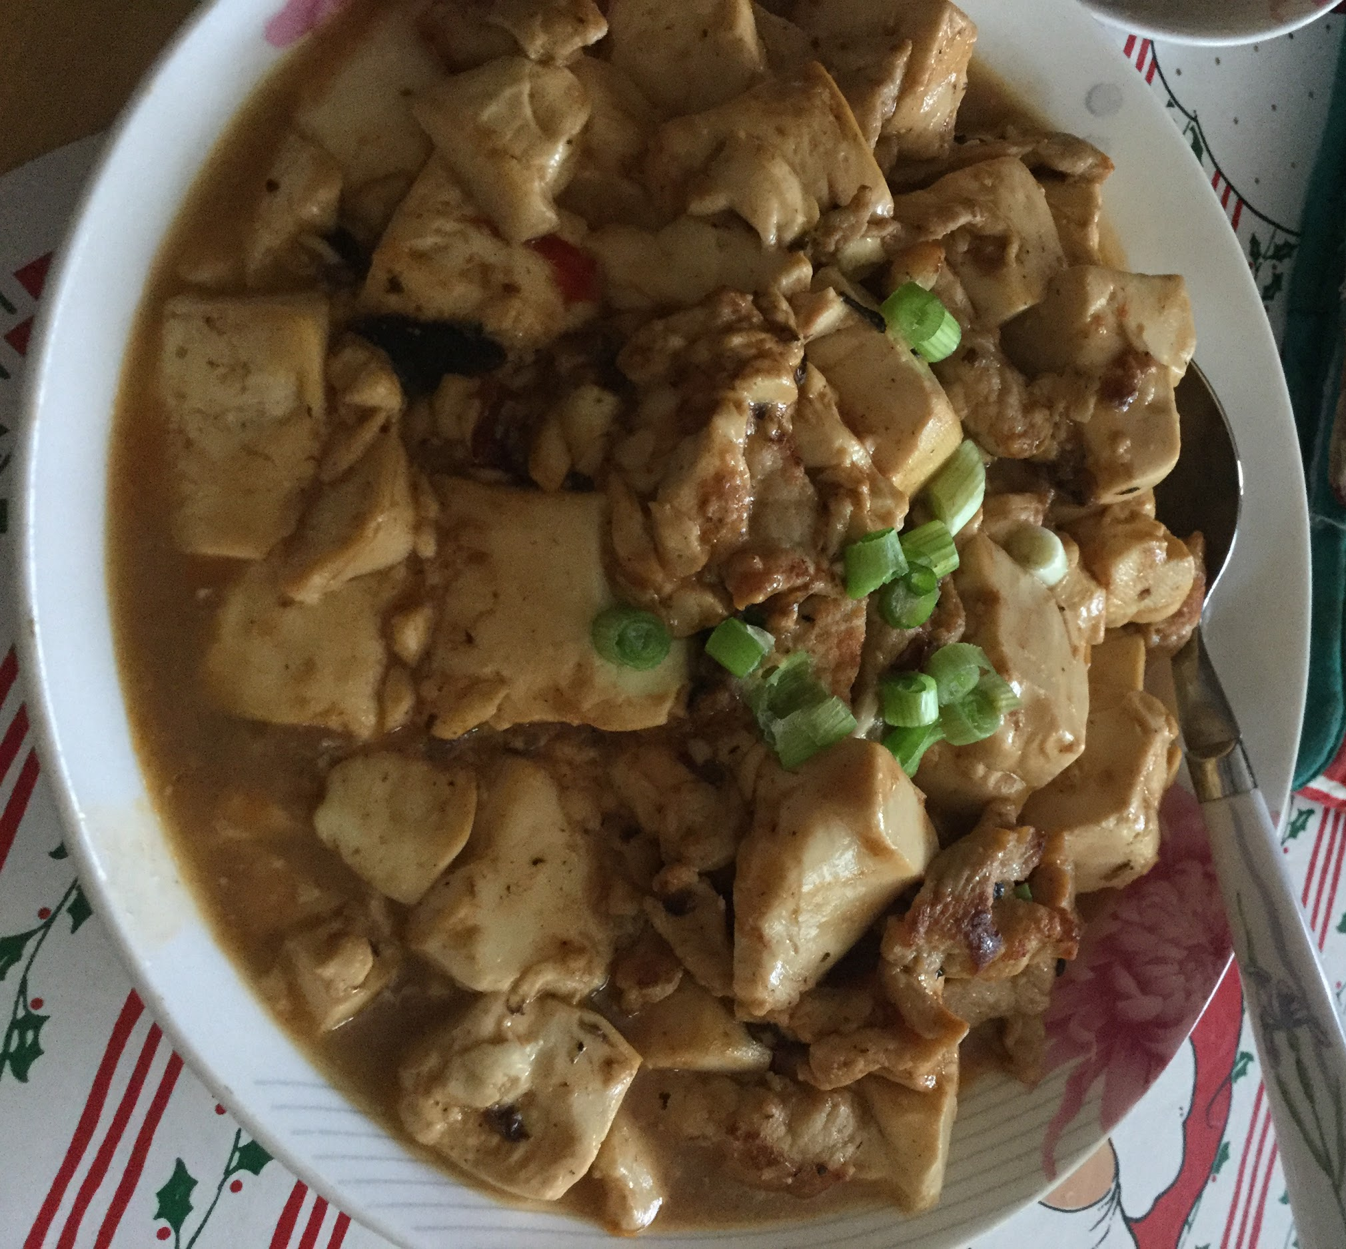
Mapo Tofu (Mince and Tofu in Spicy Sauce)
Ingredients needed:-2 tbsp oil (peanut, vegetable or canola)
-1 garlic clove , minced
-1 tsp ginger , finely chopped or minced
-1/4 cup scallions/shallots , minced
-5 oz / 150 g ground/minced pork (or beef or chicken)
-2 tsp chili bean sauce , adjust to taste (see notes)
-12 oz / 300 g Firm Tofu (see notes)
Sauce:-1 cup water
-1 tbsp cornstarch
-1/2 tsp chicken or vegetable stock powder
-1 tbsp soy sauce
-1/2 tbsp sugar
-1 tbsp Hoisin Sauce
-1 tsp sesame oil
Instructions: 1. In a bowl, combine cornflour with a splash of water, mix to combine, then add remaining Sauce ingredients and mix well.
2. Cut the tofu into 1/2 "/ 1 cm cubes.
3. Heat oil in wok over high heat.
4. Add garlic and ginger and stir fry for 10 seconds.
5. Add scallions/shallots and stir fry for 30 seconds.
6. Add mince and stir fry until the outside is brown, breaking up clumps.
7. Add Chili Bean Sauce and stir fry for 30 seconds.
8. Add tofu and sauce, and gently stir to cook the sauce until it becomes thick and saucy (about 1 to 2 minutes).
9. Serve with rice.
Family feedback: Scallions in tofu is really good! Perfect spice!
Personal feedback: I really like it, when served with rice it tastes super delicious! I would definitely make it again!
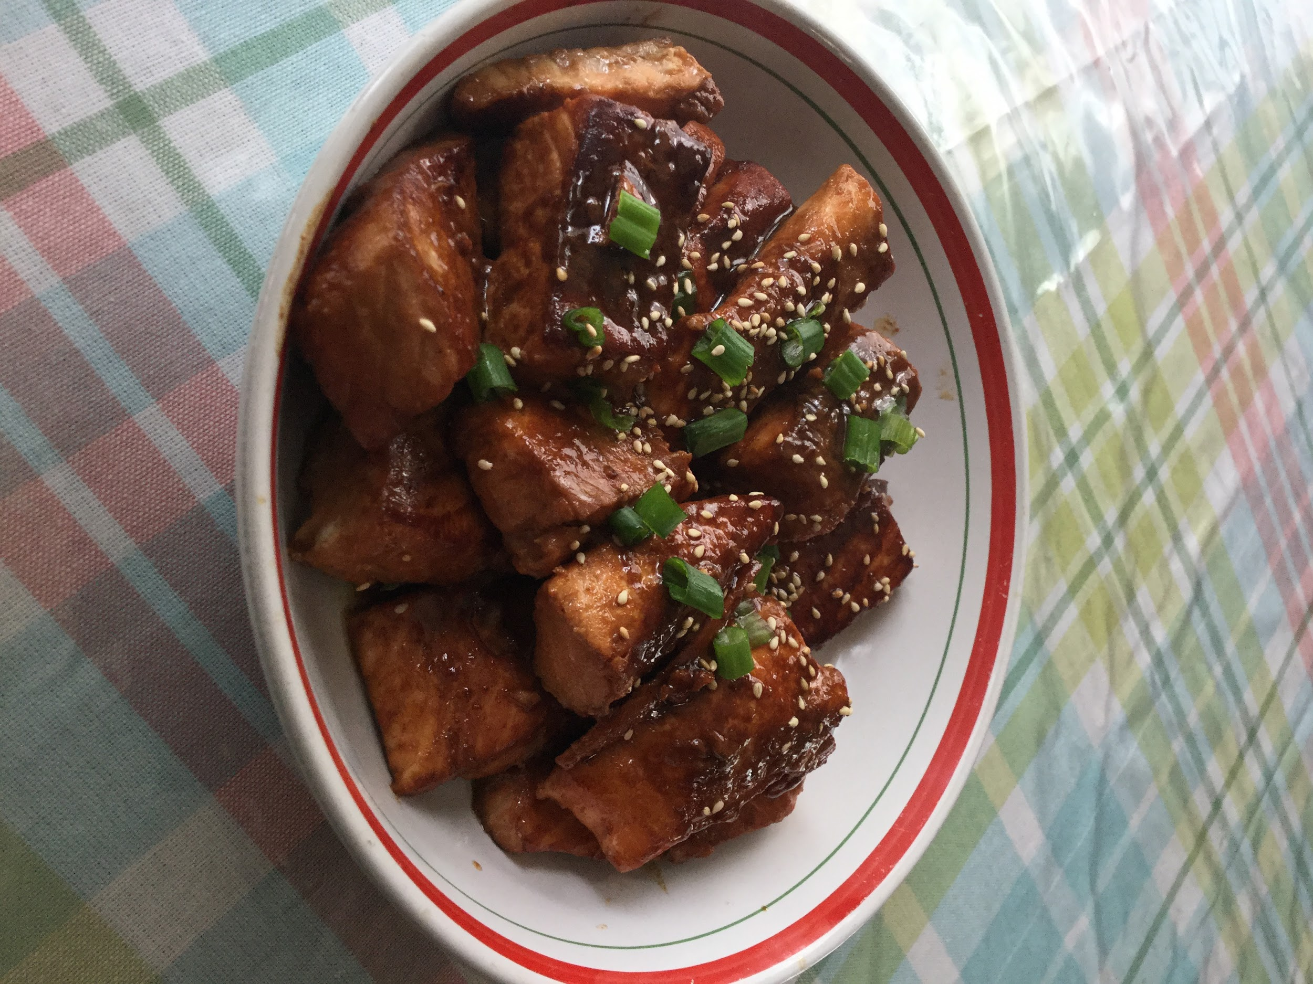
Chinese Spareribs
Ingredients needed:-3 tablespoons hoisin sauce
-1 tablespoon ketchup
-1 tablespoon honey
-1 tablespoon soy sauce
-1 teaspoon rice vinegar
-1 teaspoon lemon juice
-1 teaspoon grated fresh ginger
-½ teaspoon grated fresh garlic
-¼ teaspoon Chinese five-spice powder
-1 pound pork spareribs
Instructions: 1. In a shallow glass dish, mix together the hoisin sauce, ketchup, honey, soy sauce, sake, rice vinegar, lemon juice, ginger, garlic and five-spice powder. Place the ribs in the dish, and turn to coat. Cover and marinate in the refrigerator for 2 hours, or as long as overnight.
2. Preheat the oven to 325 degrees F (165 degrees C). Fill a broiler tray with enough water to cover the bottom. Place the grate or rack over the tray. Arrange the ribs on the grate.
3. Place the broiler rack in the center of the oven. Cook for 40 minutes, turning and brushing with the marinade every 10 minutes. Let the marinade cook on for the final 10 minutes to make a glaze. Finish under the broiler if desired. Discard any remaining marinade.
Family feedback: Love it! Just eating it is a bit messy. Maybe the sauce is slightly spicy.
Personal feedback: From the feedback from my family, next time I would add less ketchup, hoisin sauce, and soy sauce based on the recipe.
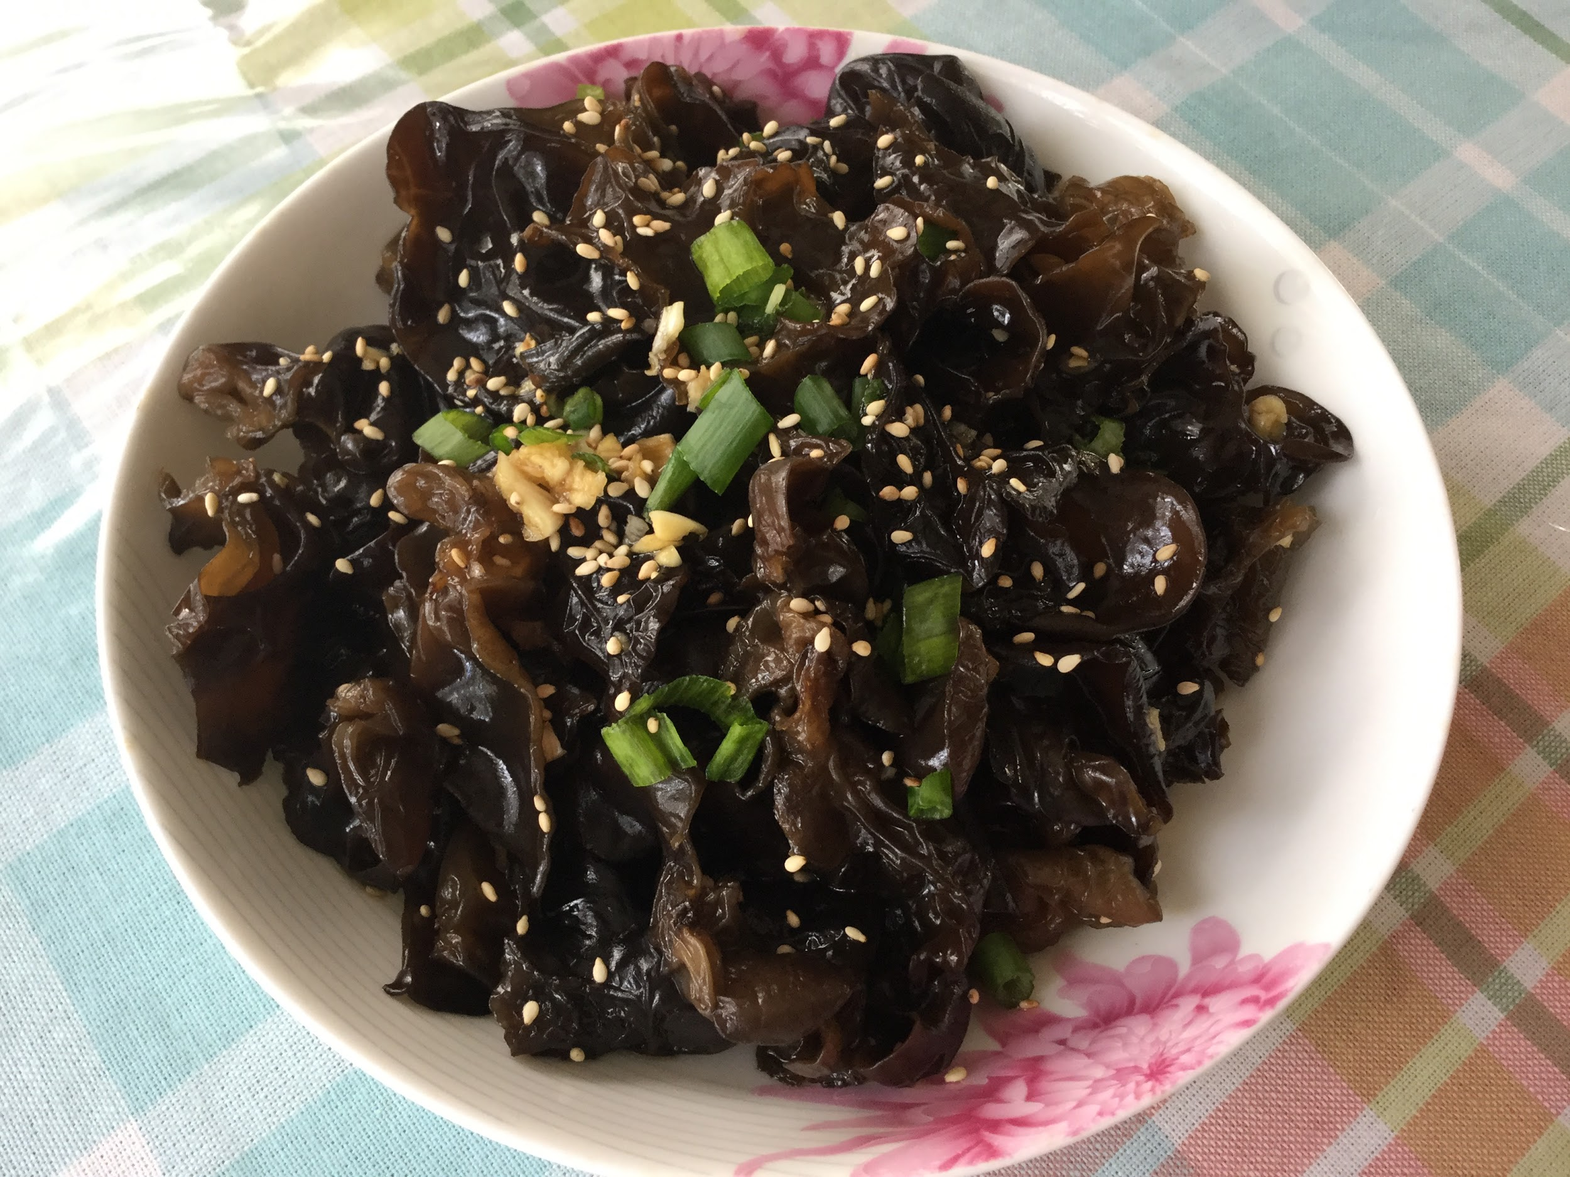
Wood Ear Mushroom Salad
Ingredients needed:-1/4 cup dried wood ear mushrooms
-1/4 middle size onion
Seasonings:-2 garlic clove , chopped
-2 tbsp. vegetable cooking oil
-3 spring onion white , cut into small sections
-1 tbsp. Chinese black vinegar
-2 tbsp. light soy sauce
-1/2 tbsp. sesame oil
-Pinch of salt if necessary
-1 tbsp, of toasted sesame seeds (optional)
Instructions: 1. Soak the dried mushrooms in warm water for 30 minutes until they absorb the water and become soft. Rinse in cold water. Tear larger pieces into bite size and remove the sandy ends. Wash carefully and make sure no sand is contained.
2. Cook soaked mushrooms in boiling water for around 1 to 2 minutes. Turn off fire and place the onion slices in. Transfer out immediately and soak in cold water to cool down.
3. Completely drain the wood ear mushrooms and then place in a serving plate.
4. Heat oil in a pot, spring onion until aromatic over slowest fire. Turn off fire and add all the other seasonings. Mix well and serve.
Family feedback: Love the crunch of the wood ears, topped off with garlic, onion and sesame seeds.
Personal feedback: I think everyone in my family liked what I've made, so I will try to add some thai peppers and garlic for a different taste.

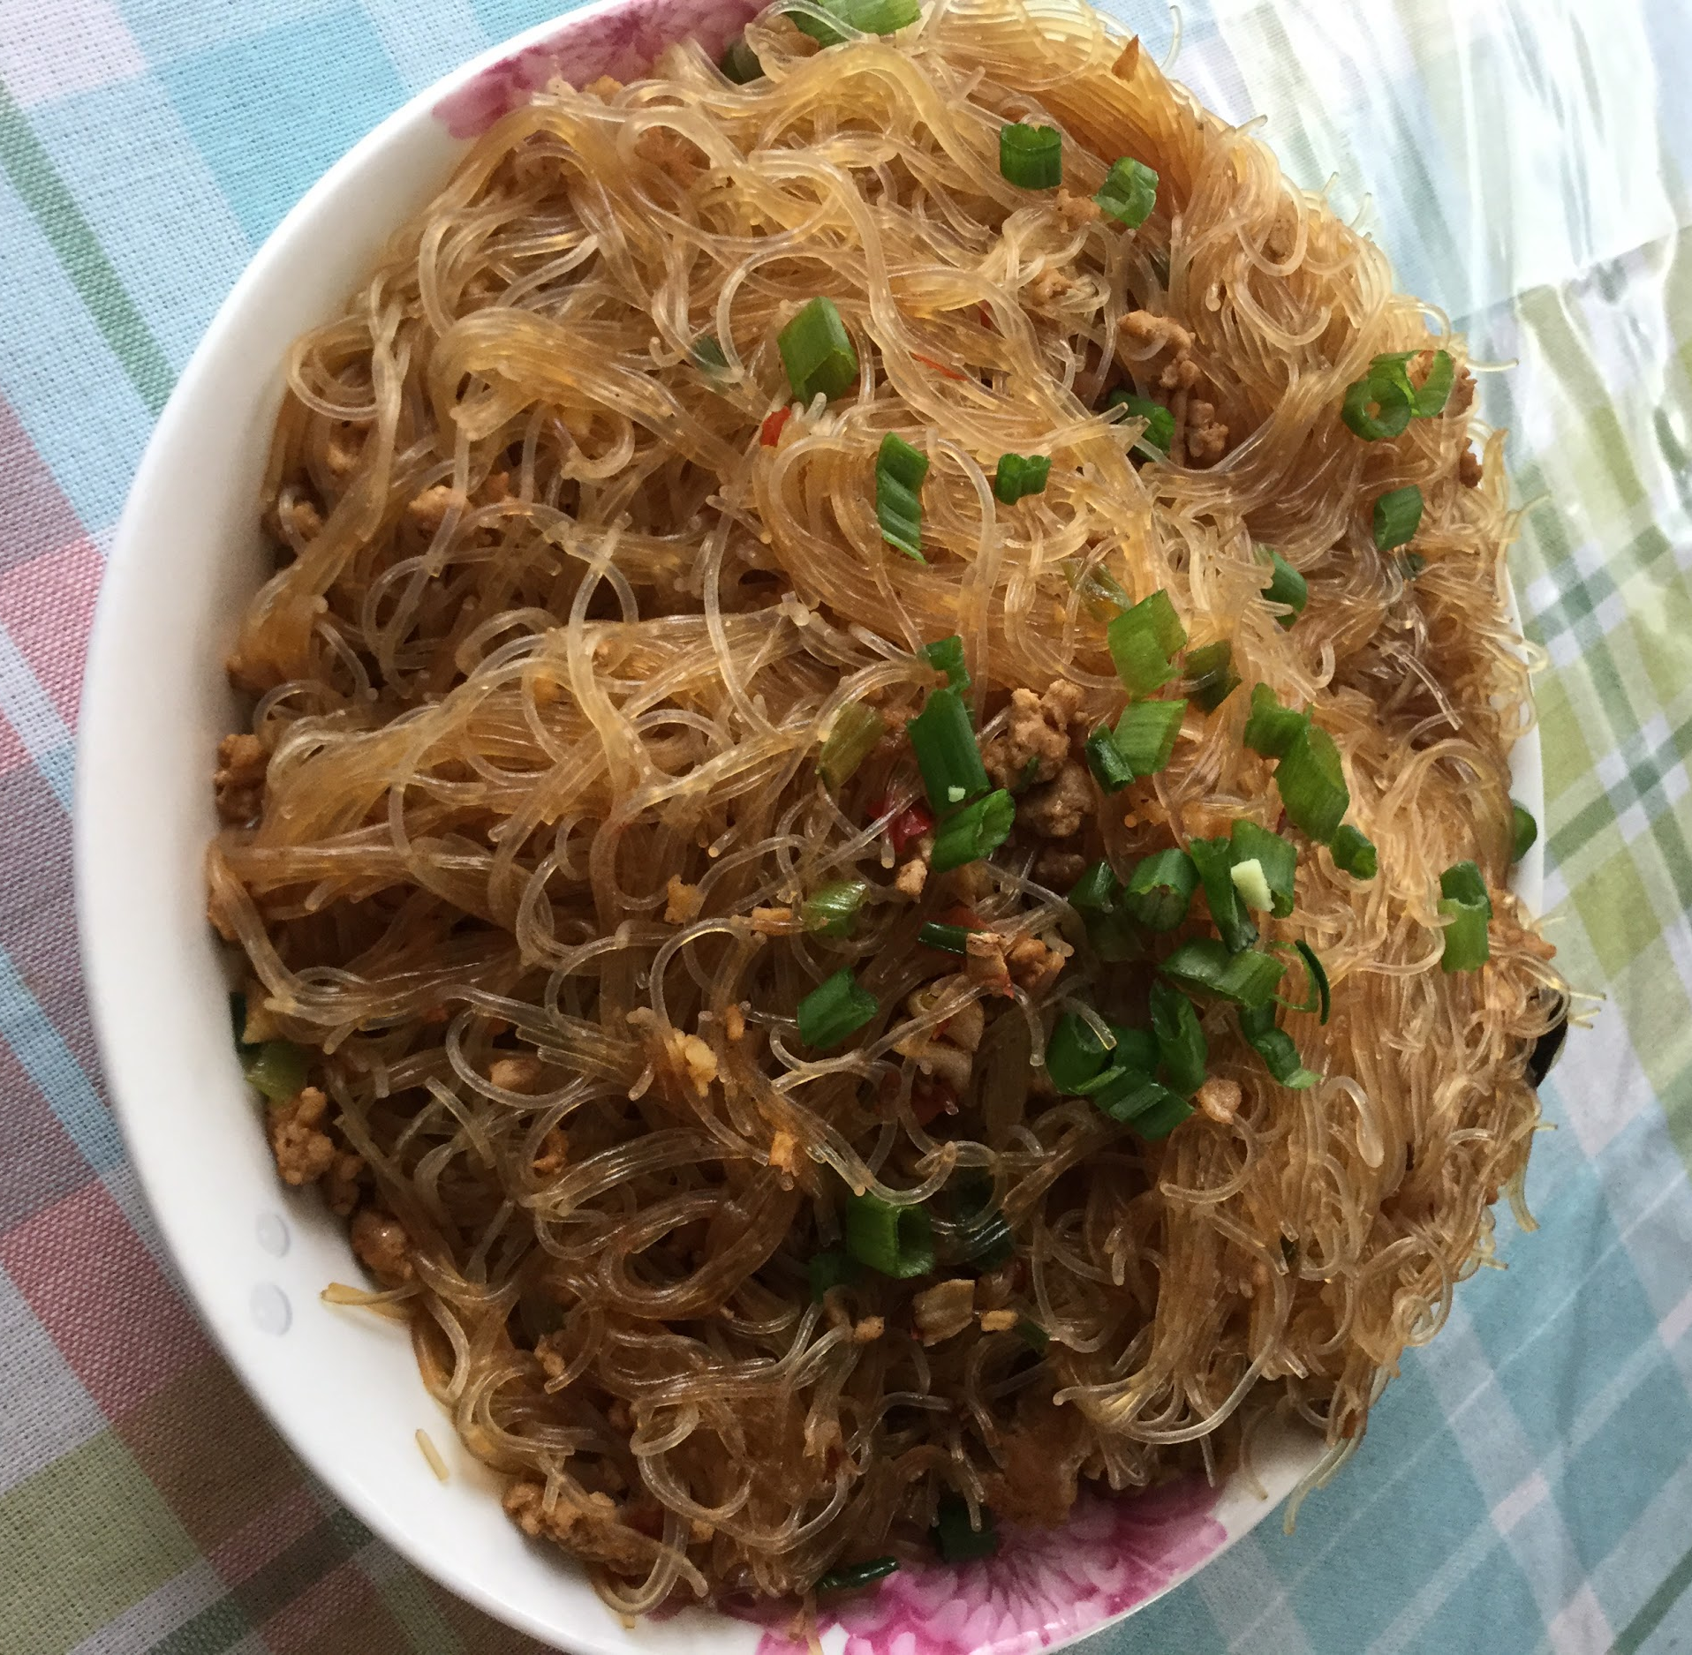
Minced Pork Vermicelli
Ingredients needed:-2 servings vermicelli
-1 cup minced pork
-2 tablespoons chopped green onion
-2 tablespoons minced garlic
-2 tablespoons minced ginger
-3 tablespoons oil
Seasonings:-1 tablespoon dark soy sauce
Instructions: 1. Immerse the vermicelli under hot water for about 10 minutes, drain, rinse under cold water, drain well again and set aside.
2. Heat oil in a pan over medium heat, add in garlic, green onion and ginger and stir fry for about 1 minute or until fragrant.
3. Stir in the ground pork and stir fry for another 1-2 minutes until the pork is no longer pink.
4. Toss in the dark soy sauce
5. Add in 2 cups of water and turn to high heat, mix all the ingredients well, wait until the water starts to boil, slowly add in the vermicelli, cook for about 2-3 minutes until the water has almost gone.
6. Top with fresh chopped green onion to serve.
Family feedback: Prefection! Vermicelli tastes really good with the minced pork!
Personal feedback: I love how this recipe turned out, currently I have nothing I would want to change to the recipe.
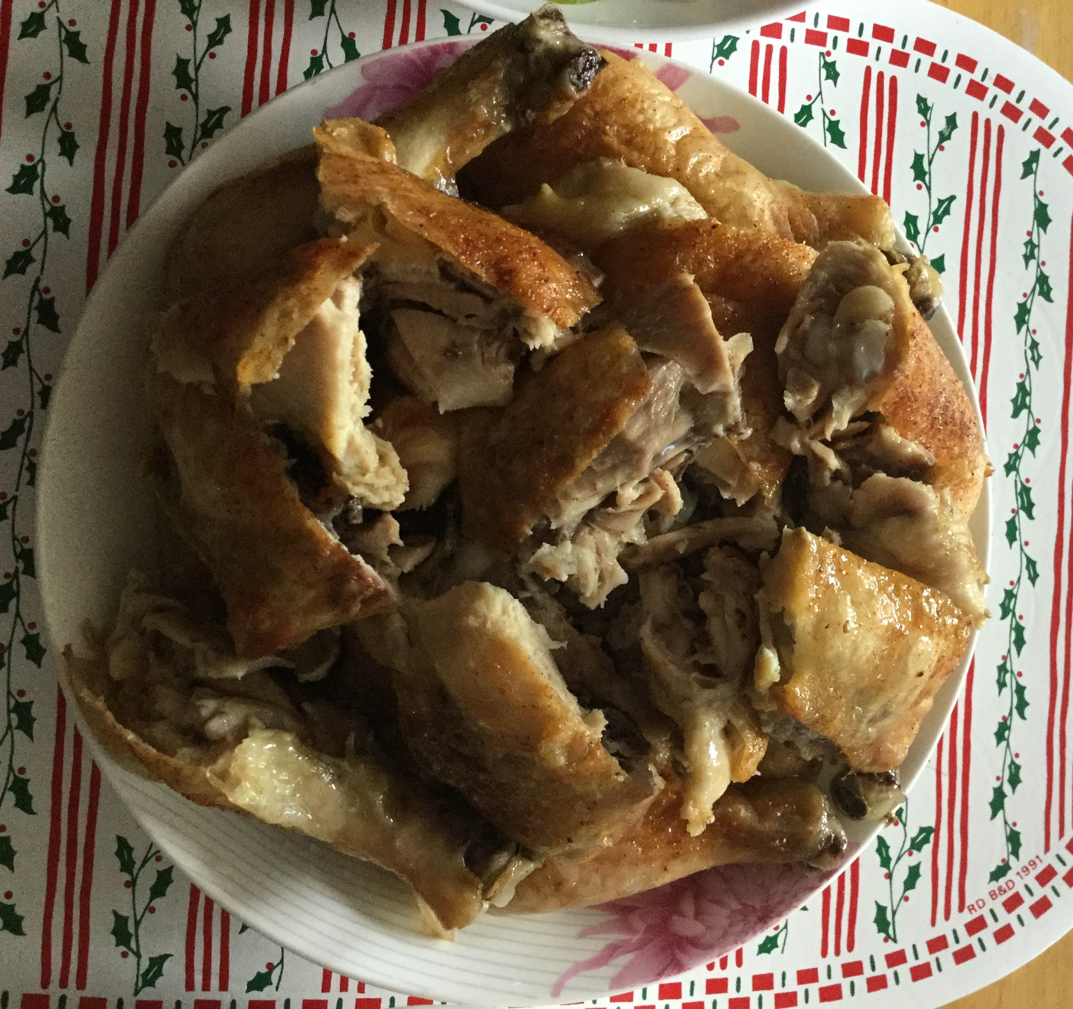
Chinese-Style Fried Chicken
Ingredients needed:-1(1.2kilos) chicken, cleaned
-1 bundle green onion
-1/2 cup soy sauce
-1/4 cup chinese cooking wine (shaoxing wine)
-1 tablespoon garlic, minced
-1 1/2 teaspoons five-spice powder
-1/2 teaspoon pepper
-Cooking oil, (such as vegetable, corn, canola, or peanut oil)
-1 cup chicken stock, or 1/4 chicken bouillon cube dissolved in 1 cup hot water
-1 tablespoon soy sauce
- Sprinkle of salt
-Sprinkle of pepper
-1 1/2 tablespoons cornstarch, dissolved in 2 tablespoons water
Instructions: 1. Stuff chicken with lemongrass and green onions; set aside
2. Mix together soy sauce, cooking wine, garlic, five-spice powder, salt, and pepper in a bowl. Mix until well incorporated.
3. Place chicken and soy sauce mixture in a large zip top bag. Seal and marinate in the refrigerator overnight.
4. Meanwhile, make the gravy: combine chicken stock, sugar, soy sauce, five-spice powder, and star anise in a saucepan. Bring to a boil, then reduce to a simmer. Season to taste with salt and pepper. Add dissolved cornstarch and cook until the sauce thickens. Turn off heat and remove star anise pieces. Set aside and keep warm.
5. To cook chicken, preheat a steamer. Drain chicken, reserving the marinade. Steam chicken for 15 minutes. Remove from the steamer and brush reserved marinade all over the chicken. Refrigerate for 15 minutes.
6. Preheat oil in a deep, heavy-bottomed pan until it registers 350°F on a deep-fry thermometer. Cut chicken into quarters or into 8 pieces. Deep-fry in batches just until the skin is golden and crisp. Drain on paper towels to remove excess oil.
7. Serve immediately with gravy on the side. (I ate with rice)
Family feedback:

