Cooking Challenge Option #2
Breakfast
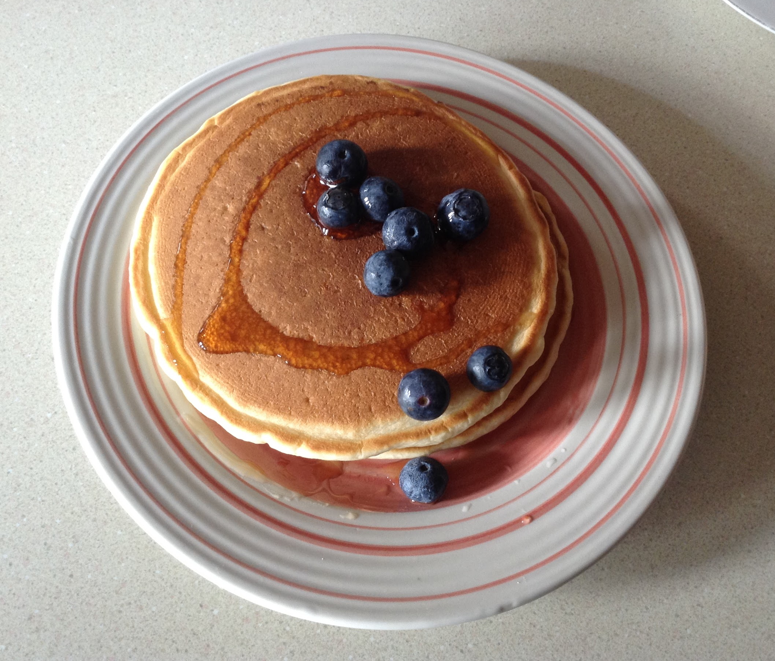
Extra-Fluffy Pancakes
Ingredients needed: -President’s Choice Original Extra-Fluffy pancake and waffle mix
-Water
-Large bowl
-Skillet
-Maple Syrup (optional)
-Fruits (optional)
Instructions: 1. Preheat a non-stick skillet over medium-high heat. In a large bowl, combine mix and water. Stir until combined but still slightly lumpy.

2. Pour slightly less than ¼ cup (50ml) batter for each pancake onto a hot, lightly greased skillet. Turn when bubbles appear on top and bottoms are golden. Cook until the second side is golden. Serve with butter and maple syrup. In addition, you can add fruits.
Feedback from my family: Nicely cooked, perfect color! Very fluffy and soft!
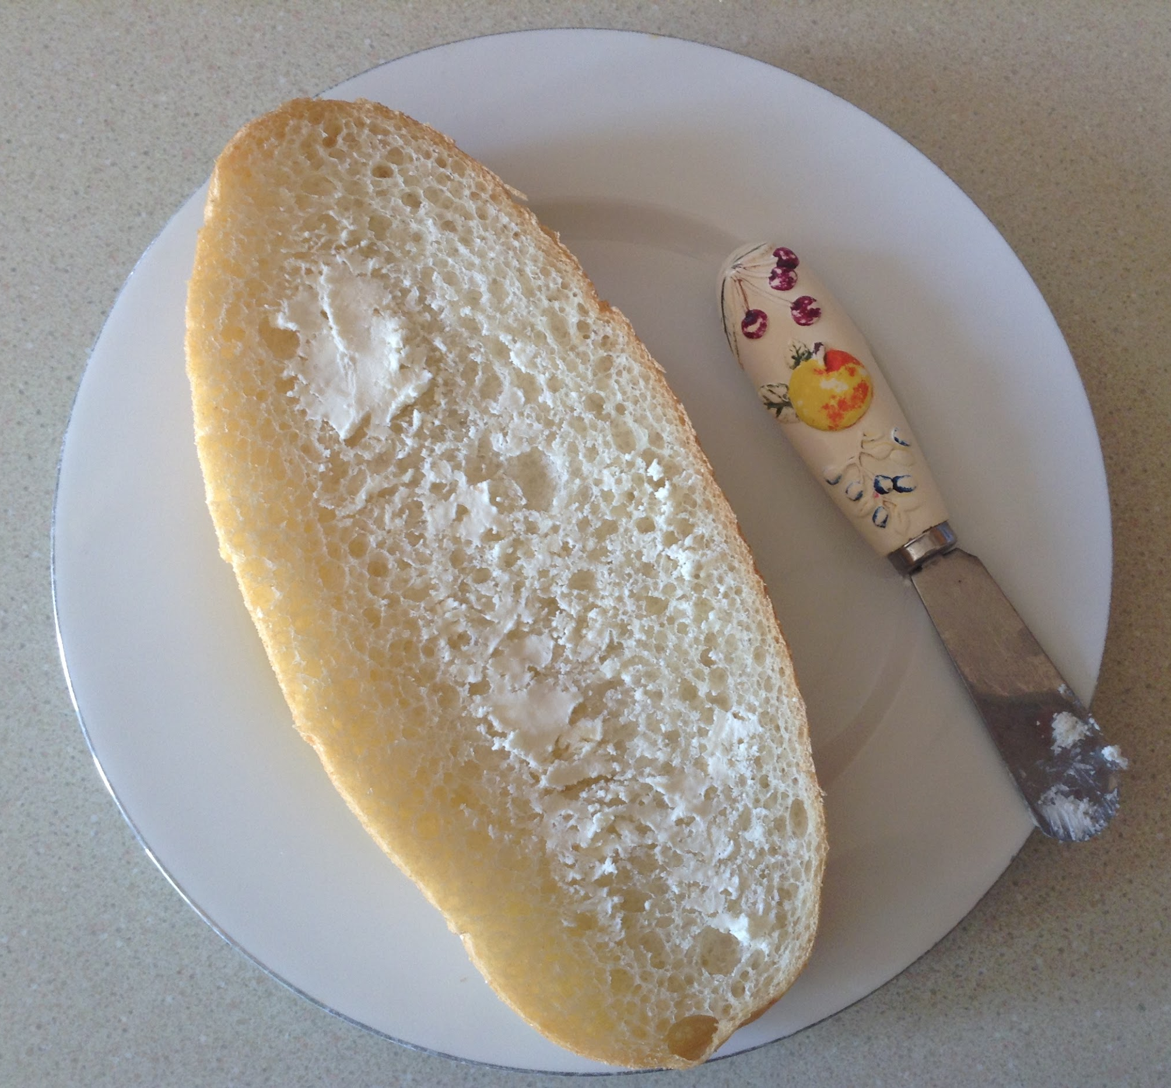
Personal feedback: I think I incorporated the mix nicely, just at the bottom it was slightly burnt. Next time I wouldn’t heat it in a skillet for that long.

Italian Bread Ingredients needed: For the sponge: -2 cups bread flour
-1 cup of warm water
-¼ tsp instant yeast
For the dough: - 3- 3 ½ cups of bread flour
-1 tsp of instant yeast
- 1 ¼ cups of warm water
-2 tsp of salt
Instructions: To make the sponge: 1. Mix together the flour, water, and yeast together in a medium bowl. Sit until it resembles dough. Cover with plastic wrap and let it sit ( dough will rise and fall) at room temperature around 6 to 24 hours.
To make the dough: 1. Combine 3 cups of bread flour and yeast in the bowl of your stand mixer. Using the dough hook, turn the mixer on low and slowly add the water while the mixer is running. Let this mix for 2 minutes until the dough starts to come together. Lift the head of your stand mixer and place a piece of plastic wrap tightly over the bowl. Let the dough rest for 20 minutes.
2. After the 20 minute rest, remove the plastic wrap. Add the sponge and salt. Knead for 8 minutes. After 4 minutes, if the dough is sticking to the side of the bowl add the last 1/2 cup of flour a little at a time. The dough should slap the sides of the bowl but still stick to the bottom (you do want it to stick to the bottom). Turn the dough out onto a lightly floured surface and form into a smooth round ball.
3. Place the dough in a large, lightly oiled bowl, and cover tightly with greased plastic wrap. Let the dough rise in a warm spot until doubled, about an hour.
4. After the dough has doubled, remove the plastic wrap. After the dough has risen for about an hour, it’s time to start turning it. Slide a plastic bench scraper or rubber spatula one side of the dough; gently lift and fold a third of the dough toward the center.Let rest for 30 minutes.
5. Repeat the previous step after the 30 minutes are up and then let it rise for a second 30 minutes.
6.After the second 30 minutes of rising, it’s time to form the loaf. Remove the dough from the bowl and gently press it into a 10-inch square. Gently dimple it. Fold each corner diagonally into the middle. Using your fingertips and starting at the top of the dough, pull the underside of the dough up over the top, stretching it considerably, and begin to roll the dough up into a rough log. With each roll, press the seam firmly to seal. Continue to do this, forming the dough into a fairly tight log, 5 to 7 more times.
7.Place the dough, seam down, on a rimless baking sheet (or one that is upside-down) that is lined with parchment paper. Gently tuck the dough into place on the parchment. You should end up with a long thin loaf that is 16 inches long. Transfer dough to a lined inverted baking sheet or parchment lined pizza paddle.
8.Finish shaping the loaf into a taut 16-inch-long torpedo-shaped loaf by tucking the edges under with your hands. Lightly mist the dough with oil and cover loosely with plastic wrap. Let the dough rise in a warm place until doubled, 1 to 1 1/2 hours.
9.While the dough is rising, prep the oven and your baking stone. Preheat the oven to 500 degrees. Let the baking stone heat for 30 minutes (but not longer than an hour).
10.When the dough has doubled, score the top with a razor blade, diagonally and 1/2 inch deep and spray lightly with water. Carefully slide the loaf and the parchment onto the hot baking stone in the oven. Bake for 10 minutes.
11.After 10 minutes reduce the oven temperature to 400 degrees. Bake for 30 to 35 more minutes until the crust is a deep golden brown. Let the loaf cool completely on a wire rack until it is room temperature. (about 2 hours cooling time) Serve and enjoy! You can add cream cheese or butter on top. Family feedback: Very Fresh! Just the bread is slightly hard. But if you put it in the toaster, it’s the perfect texture! Personal feedback: I cooked my bread in the oven for too long. Next time, bake for 30 to 35 minutes.
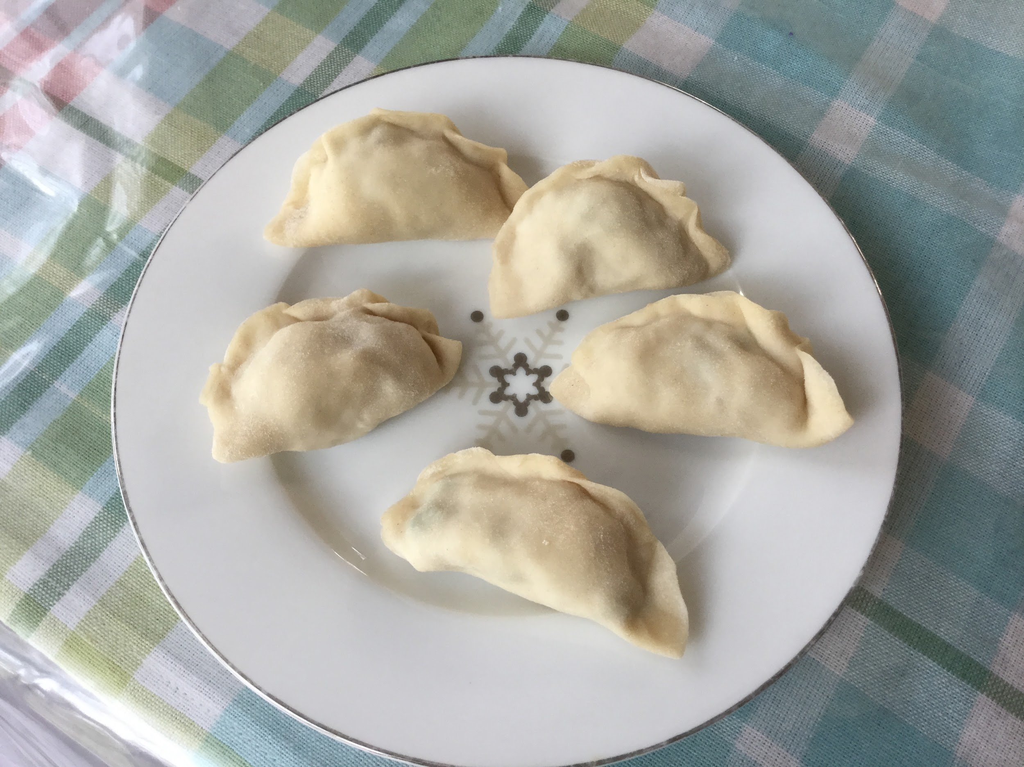
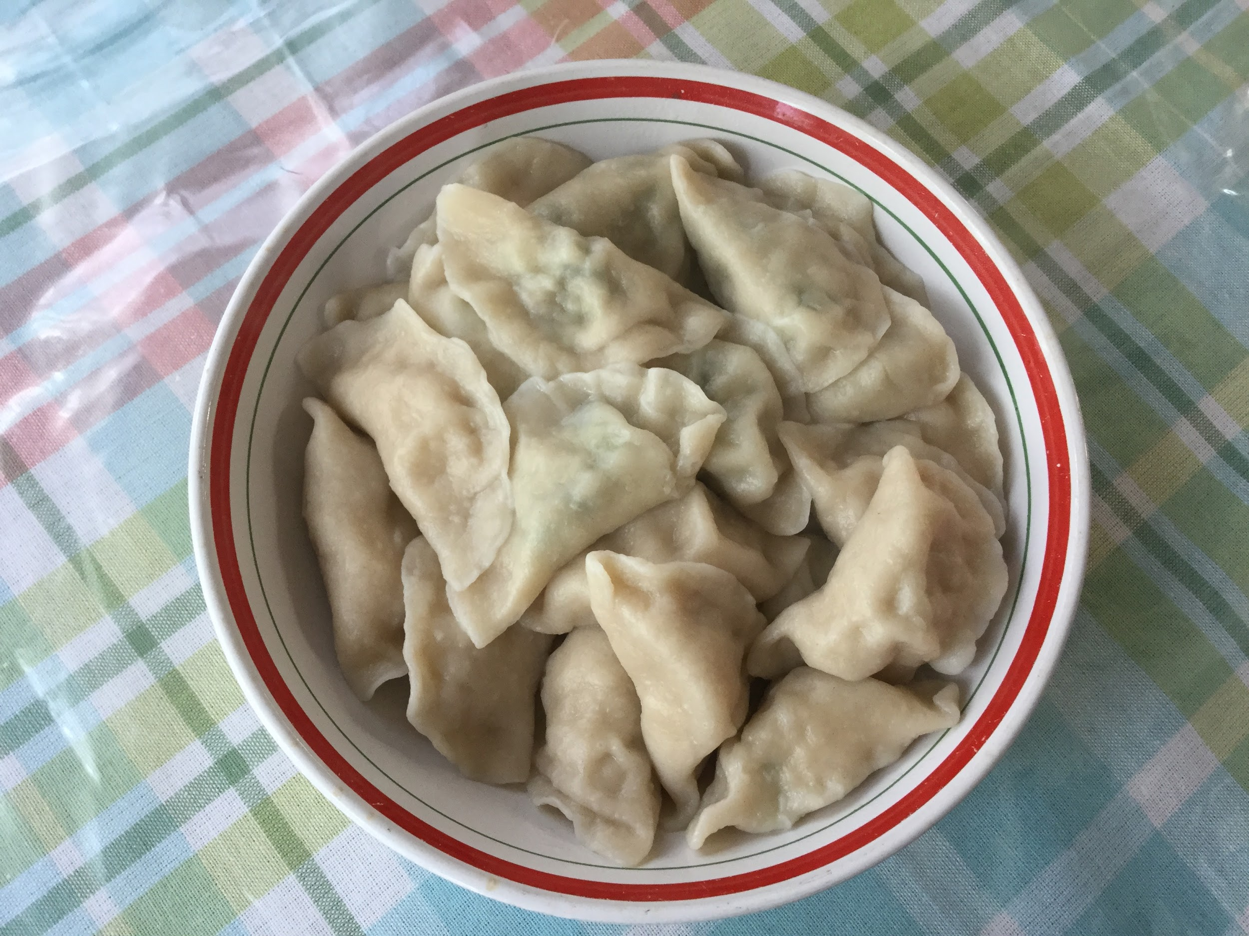
Chinese Pork Dumplings Ingredients needed:- ½ cup soy sauce
-1 tablespoon seasoned rice vinegar
-1 tablespoon finely chopped Chinese chives
-1 tablespoon sesame seeds
-1 teaspoon chile-garlic sauce (such as Sriracha®)
-1 pound of ground pork
-3 cloves garlic, minced
-1 egg, beaten
-2 tablespoons finely chopped Chinese chives
-2 tablespoons soy sauce
-1 ½ tablespoons sesame oil
-1 tablespoon minced fresh ginger
-50 dumpling wrappers
-1 cup of vegetable oil for frying
-1 quart water, or more as needed
Instructions: 1. Combine 1/2 cup soy sauce, rice vinegar, 1 tablespoon chives, sesame seeds, and chile sauce in a small bowl. Set aside.
2. Mix pork, garlic, egg, 2 tablespoons chives, soy sauce, sesame oil, and ginger in a large bowl until thoroughly combined. Place a dumpling wrapper on a lightly floured work surface and spoon about 1 tablespoon of the filling in the middle. Wet the edge with a little water and crimp together forming small pleats to seal the dumpling. Repeat with remaining dumpling wrappers and filling.
3. Heat 1 to 2 tablespoons vegetable oil in a large skillet over medium-high heat. Place 8 to 10 dumplings in the pan and cook until browned, about 2 minutes per side. Pour in 1 cup of water, cover and cook until the dumplings are tender and the pork is cooked through, about 5 minutes. Repeat for remaining dumplings. Serve with soy sauce mixture for dipping. Photo above is dumplings before being cooked. Second photo above is when the dumplings are cooked. Dumplings are leftovers from dinner from the previous night. Family Feedback: Taste delicious! Just the pork inside was a little bit salty. Personal feedback: Next time, don’t add so much soy sauce into pork mixture. Next time, don’t add sesame oil, it creates a nutty flavor that doesn’t need to be in the dumplings.

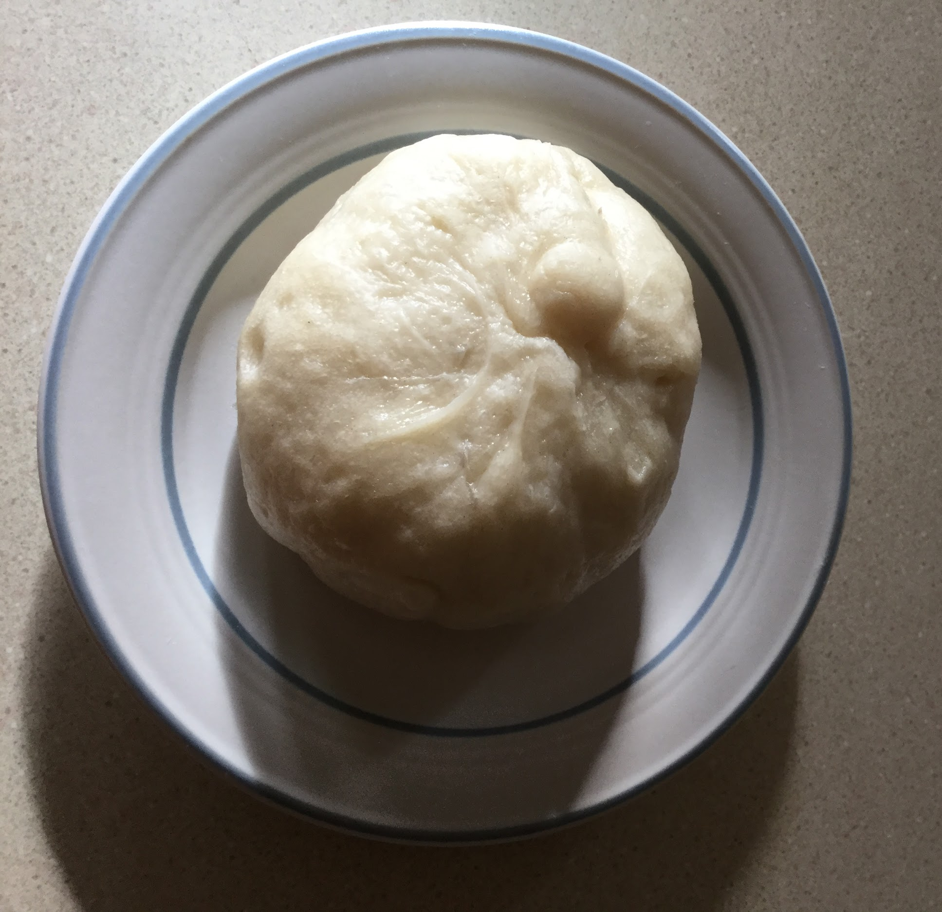
Chinese Steamed Pork Buns Ingredients needed: Yeast activation:-1 tsp active dry yeast powder
-¼ cup (65ml) warm water
-1 tbsp of white sugar
Dough: -½ (125ml) of warm water
-4 tbsp (70g) white sugar
- 2 cups (300g) All Purpose plain flour
-1 cup (155g) cornstarch
-¼ cup (65ml) of vegetable oil
-2 ½ tsp of baking powder
Pork Filling: -1 tbsp vegetable oil
-⅓ cup of finely chopped eschalot or white onion
-1 tbsp of sugar
-1 ½ tbsp of soy sauce
-1 tbsp sesame oil
-½ cup of water
-1 tbsp cornflour dissolved in 1 tbsp of water
-1 ½ cups of Chinese Barbecue Pork
Instructions: Dough: 1. Yeast Activation: Place yeast, sugar and water in a small bowl. Mix, then set aside for 10 minutes until it becomes foamy. . 2. Place flour, cornflour and sugar in a stand mixer bowl fitted with a dough hook. Mix briefly to combine. 3. Add yeast mixture, oil and water. Mix on low speed for 3 minutes until a smooth ball of dough forms. It should be soft and elastic, not so sticky it gets stuck all over your hands. Adjust with a touch of flour/water if required to get the dough consistency right. 4. Cover with cling wrap and place in a warm dry place for 2 hours until it doubles in volume. (Note 3). Meanwhile, make Filling.
5.Remove cling wrap, scatter over baking powder. Return to the stand mixer and mix on low for 2 minutes.
6.Turn dough out onto the work surface, sprinkle with flour. Knead lightly to form a smooth round disc.
Making buns: 1. Cut dough into 4 pieces. Take one piece, roll into an even log, cut into 3 pieces (so 12 pieces in total).
2.Take one piece of dough, cover remaining with cling wrap or tea towel.
3.Roll into round 4.5" / 11 cm in diameter, making the edges thinner.
4.Place dough in hand, put 1 1/2 tbsp of Filling in the centre.
5.Pinch 8 pleats around the edges. Then gather the pleats together one by one to seal the bun. Pinch the top the twist.
6.Repeat with remaining dough - make 12 in total.
7.Cover buns loosely with cling wrap and leave in a warm place for 15 minutes
Steaming: 1.Line a large bamboo steamer (or other steamer) with parchment paper punctured with holes (Note 4).
2.Place 6 to 8 buns on paper, covered with a steamer lid.
3.Pour about 4 cm / 1 1/2 inches in a wok / pot (steamer should not touch water) and bring to a rapid simmer over medium high.
4.Place steamer in wok, then cook for 12 minutes. Check water halfway through, top up if required.
5.Buns are ready when they spring back when touched, and the buns have formed a smooth skin.
6.Remove steamer from wok, serve warm!
Filling: 1.Heat oil in a saucepan over medium heat. Add eschalots and cook for 2 minutes.
2.Add sugar, soy sauce, oyster sauce, sesame oil and water. Mix.
3.While stirring, slowly pour cornflour mixture in. Mix until smooth.
4.Stir in pork. Cook until sauce is thickened, 1 - 1 1/2 minutes (see video for consistency). Set aside to cool (thickens when cools).
Family Feedback: Just perfection! Love the taste of the steam bun. The only thing I would do is steam it slightly shorter so the texture is not too soft or hard. Personal Feedback: I would not add white onion next time. It creates a strong flavor in the pork.

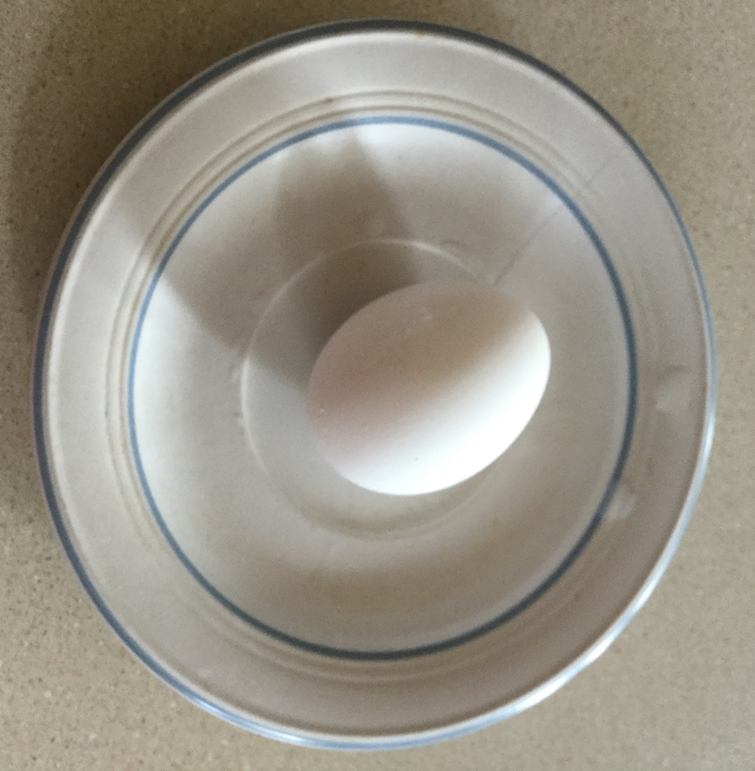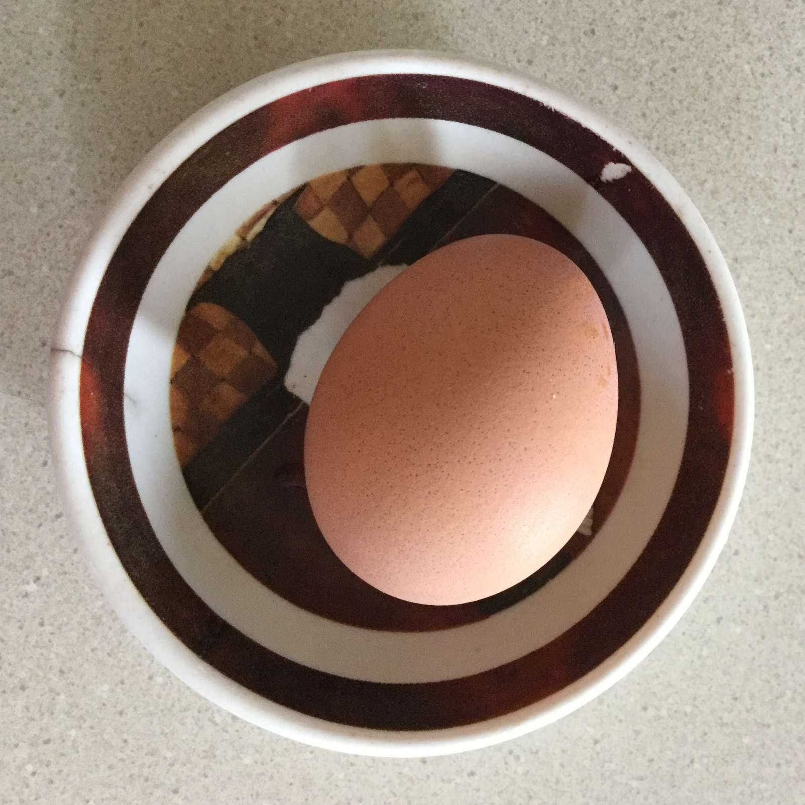
Hard Boiled Eggs
Ingredients needed:-Eggs
Instructions: 1. Place eggs into a saucepan and pour in cold water to cover; place over high heat. When the water just starts to simmer, turn off heat, cover pan with a lid, and let stand for 17 minutes. Don't peek.
2. Pour out the hot water and pour cold water over eggs. Drain and refill with cold water; let stand until eggs are cool, about 20 minutes. Peel eggs under running water.
Family feedback:The shell harder to peel, overall great!
Personal feedback: Next time after boiling the eggs, keep the eggs in cold water for longer to ensure peel can easily be taken off.
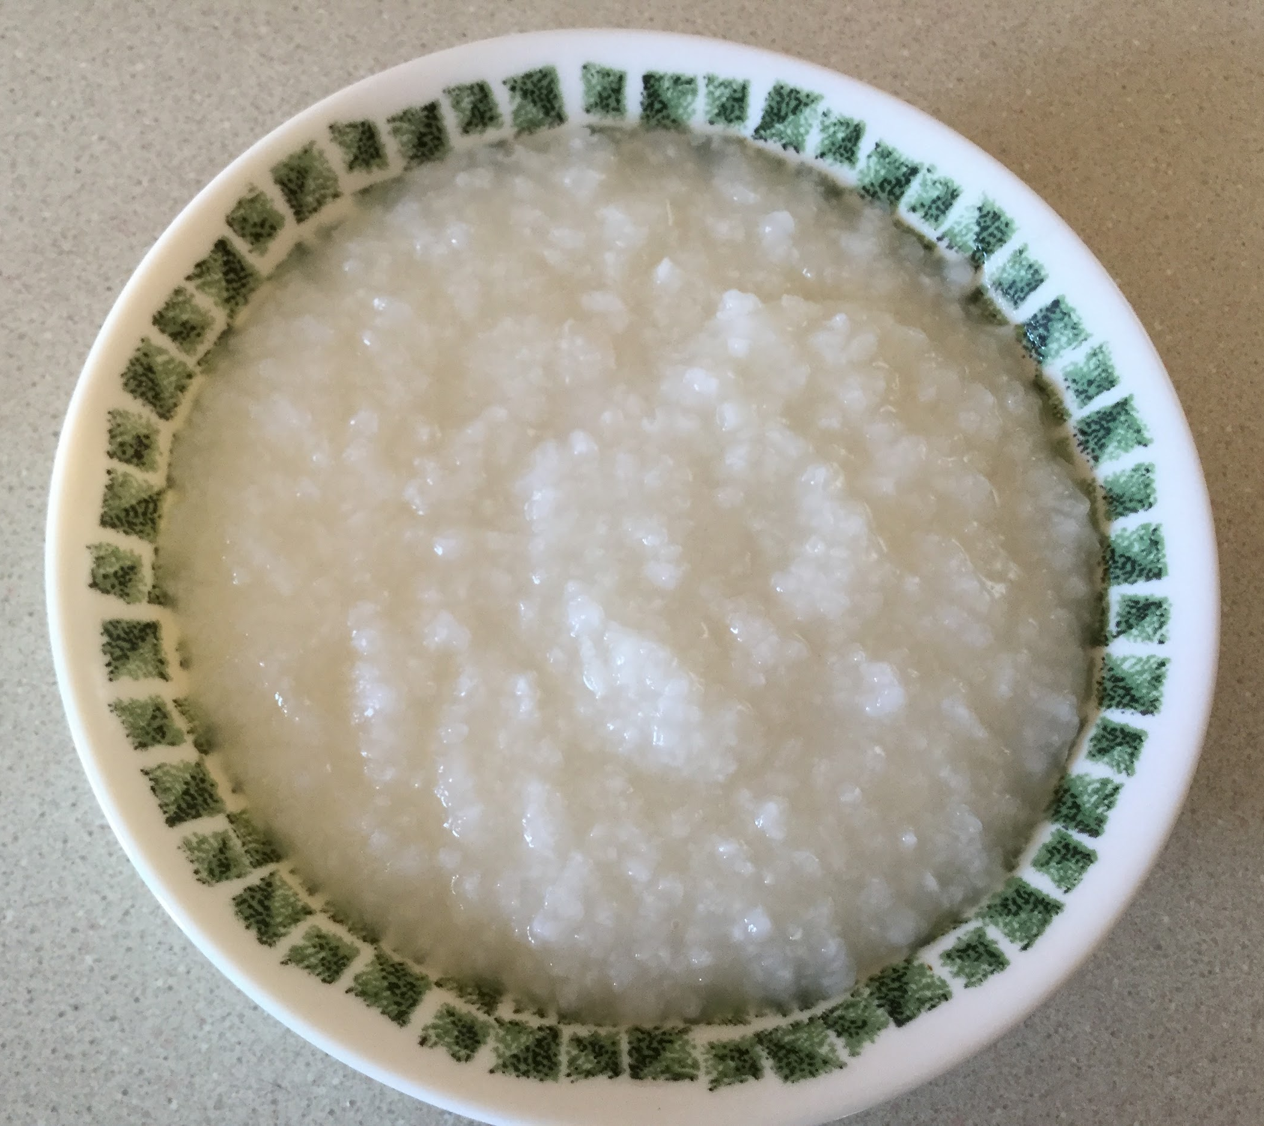
White rice Porridge
Ingredients needed:- ¼ cup (50g) uncooked short-grain rice
-1 cup +2 tsp (250ml) of water
Instructions: 1. Gather all the ingredients. I follow the 1 to 5 rice-to-water ratio
2. Rinse the rice in water, then drain. Repeat until the water runs clear.
3. Soak the rice in the pot for at least 30 minutes.
4. After 30 minutes, drain the water completely.
5. Then add 250 ml of water into the pot.
6. Cover the pot and bring to a boil over high heat.
7. When boiling, lower the heat to the stove’s lowest setting (make sure to use the right size of stove burner for your pot size). Open the lid and gently mix with the spoon once, making sure rice is not stuck to the bottom of the pot.
8. Cover the lid and simmer the rice for 30 minutes (Tip: With a good size pot and the lowest heat on the stove, the water should not boil over. If you cook with more water or your pot is smaller than my pot, you may want to cover the lid at a slight angle so the water doesn’t boil over). During this time, I never open the lid or mix the rice. (Tip: If you are worried, you can take a quick peek and make sure there’s enough water so the rice doesn’t burn the bottom of the pot. If necessary, you can stir the pot or add “hot” water. Otherwise, don’t touch the rice because you would end up breaking the nice shape of rice kernels.)
9. After 30 minutes, turn off the heat and let it steam for 10 minutes. The rice should be soft and thickened. If you want to add something, like a beaten egg or salt, this is the time to add. I keep this recipe plain and simple. Serve into the individual rice bowls and garnish and put toppings of your choice.
Family feedback: Very soft!
Personal feedback: I could add more water to make the texture more thin to drink rather than eaten.

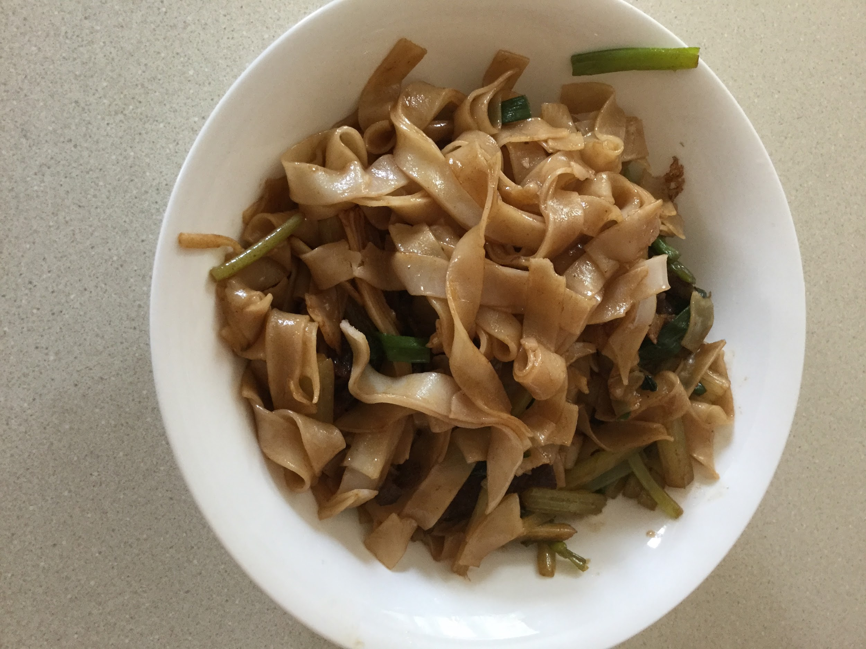
Lunch
Fried Rice Noodles
Ingredients needed:-1/2 pound (220 grams) wide dried rice noodles
Marinade:-1/2 pound (220 grams) ground meat (beef, chicken, pork, or turkey) or shrimp
-2 teaspoons Shaoxing wine (or Japanese sake, or dry sherry)
-1 teaspoon potato starch
-1/2 teaspoon salt
Sauce:-1/4 cup chicken stock
-2 teaspoons light soy sauce
-1 tablespoon dark soy sauce
-1 tablespoon sugar
-1/2 teaspoon salt (or 1 tablespoon oyster sauce, or hoisin sauce)
Stir-fry:-2 tablespoons peanut oil (or animal fat)
-6 green onions , chopped into long slices (separate the white and green parts
Instructions: 1. Cut rice noodle threads into 8-inch (20 cm) lengths with a pair of scissors and transfer them to a large bowl. Add hot tap water to cover. Be sure to submerge the rice noodles. Let sit for 5 to 7 minutes, until tender. The noodles should be flexible but remain al-dente. Drain. Add a few drops of vegetable oil and gently toss a few times.

2. While soaking the noodles, prepare marinade, sauce and cut veggies.
3. Combine ground meat (or shrimp), Shaoxing wine, potato starch, and salt in a small bowl. Mix well.
4. Combine chicken stock, light soy sauce, dark soy sauce, sugar, and salt in a small bowl. Mix well.
5. Place all the ingredients and a pair of tongs (or pair of chopsticks) next to your stove.
6. Heat oil in a large nonstick skillet (or a wok) over high heat until hot. Add ginger and half the green onion (all the white parts). Cook and stir until it starts to sizzle.
7. Add ground meat. Cook and stir until the surface is slightly charred, but not cooked through yet.
8. Add the rest of the green onion (all the green parts). Cook and stir for 30 seconds
9. Pour in sauce. Stir a few times. Add rice noodles. Toss and stir with a pair of tongs, until the liquid is fully absorbed. Remove skillet from stove. Carefully taste the noodles. If the noodles are still a bit tough, you can return the skillet to the stove and pour in 3 to 4 tablespoons chicken stock (or water). Continue tossing and stirring until the liquid is absorbed.
10. Transfer everything to serving dishes. Serve immediately as a main dish.
Family feedback: Very delicious! Just a little salty! Flavour incorporated into the rice noodles.
Personal feedback: Use precise measuring cups in order to control the amount of salt and soy sauce.
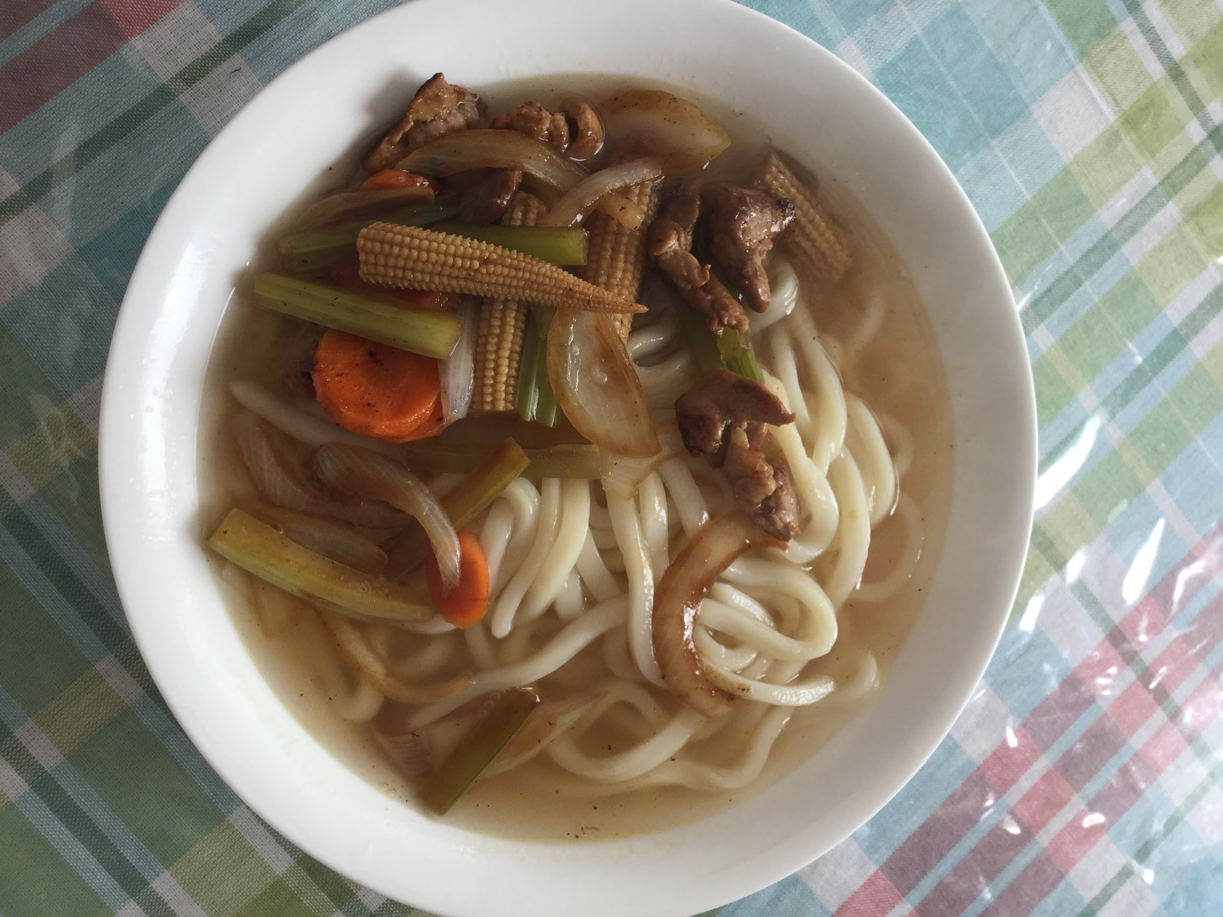

Beef Udon Noodle Soup
Ingredients needed:-8 ounces of uncooked udon noodles
-2 (14 1/2 ounce) cans of low sodium beef broth
-3 tablespoons of low sodium of soy sauce
- 8 ounces of top round beef thinly sliced
- 3⁄4 cup diagonally cut green onion
-2-3 slices of baby corn
-1⁄2 cup thinly sliced carrot
-7-8 slices of celery sticks (You can add any veggies or meat of your choice)
Instructions: 1. Cook noodles per package directions; drain.
2. Add garlic, and broth to a large saucepan; bring to a boil.
3. Lower heat, and simmer for 10 minutes.
4. Combine soy sauce, in a small bowl; stir with a whisk.
5. Heat a large nonstick skillet coated with cooking spray over med-high heat.
6. Add in baby corn, and carrots, stir/saute 2 minutes.
7. Stir in soy sauce mixture; cook for 2 minutes stirring constantly.
8. Add vegetable mixture to broth mixture; stir in beef.
9. Cook for 2 minutes or until beef loses its pink color.
10. Stir in noodles, green onions, and celery sticks.
Family feedback: Nothing to say, absolutely tasty!
Personal feedback: I would repeat this recipe; everyone loved it.

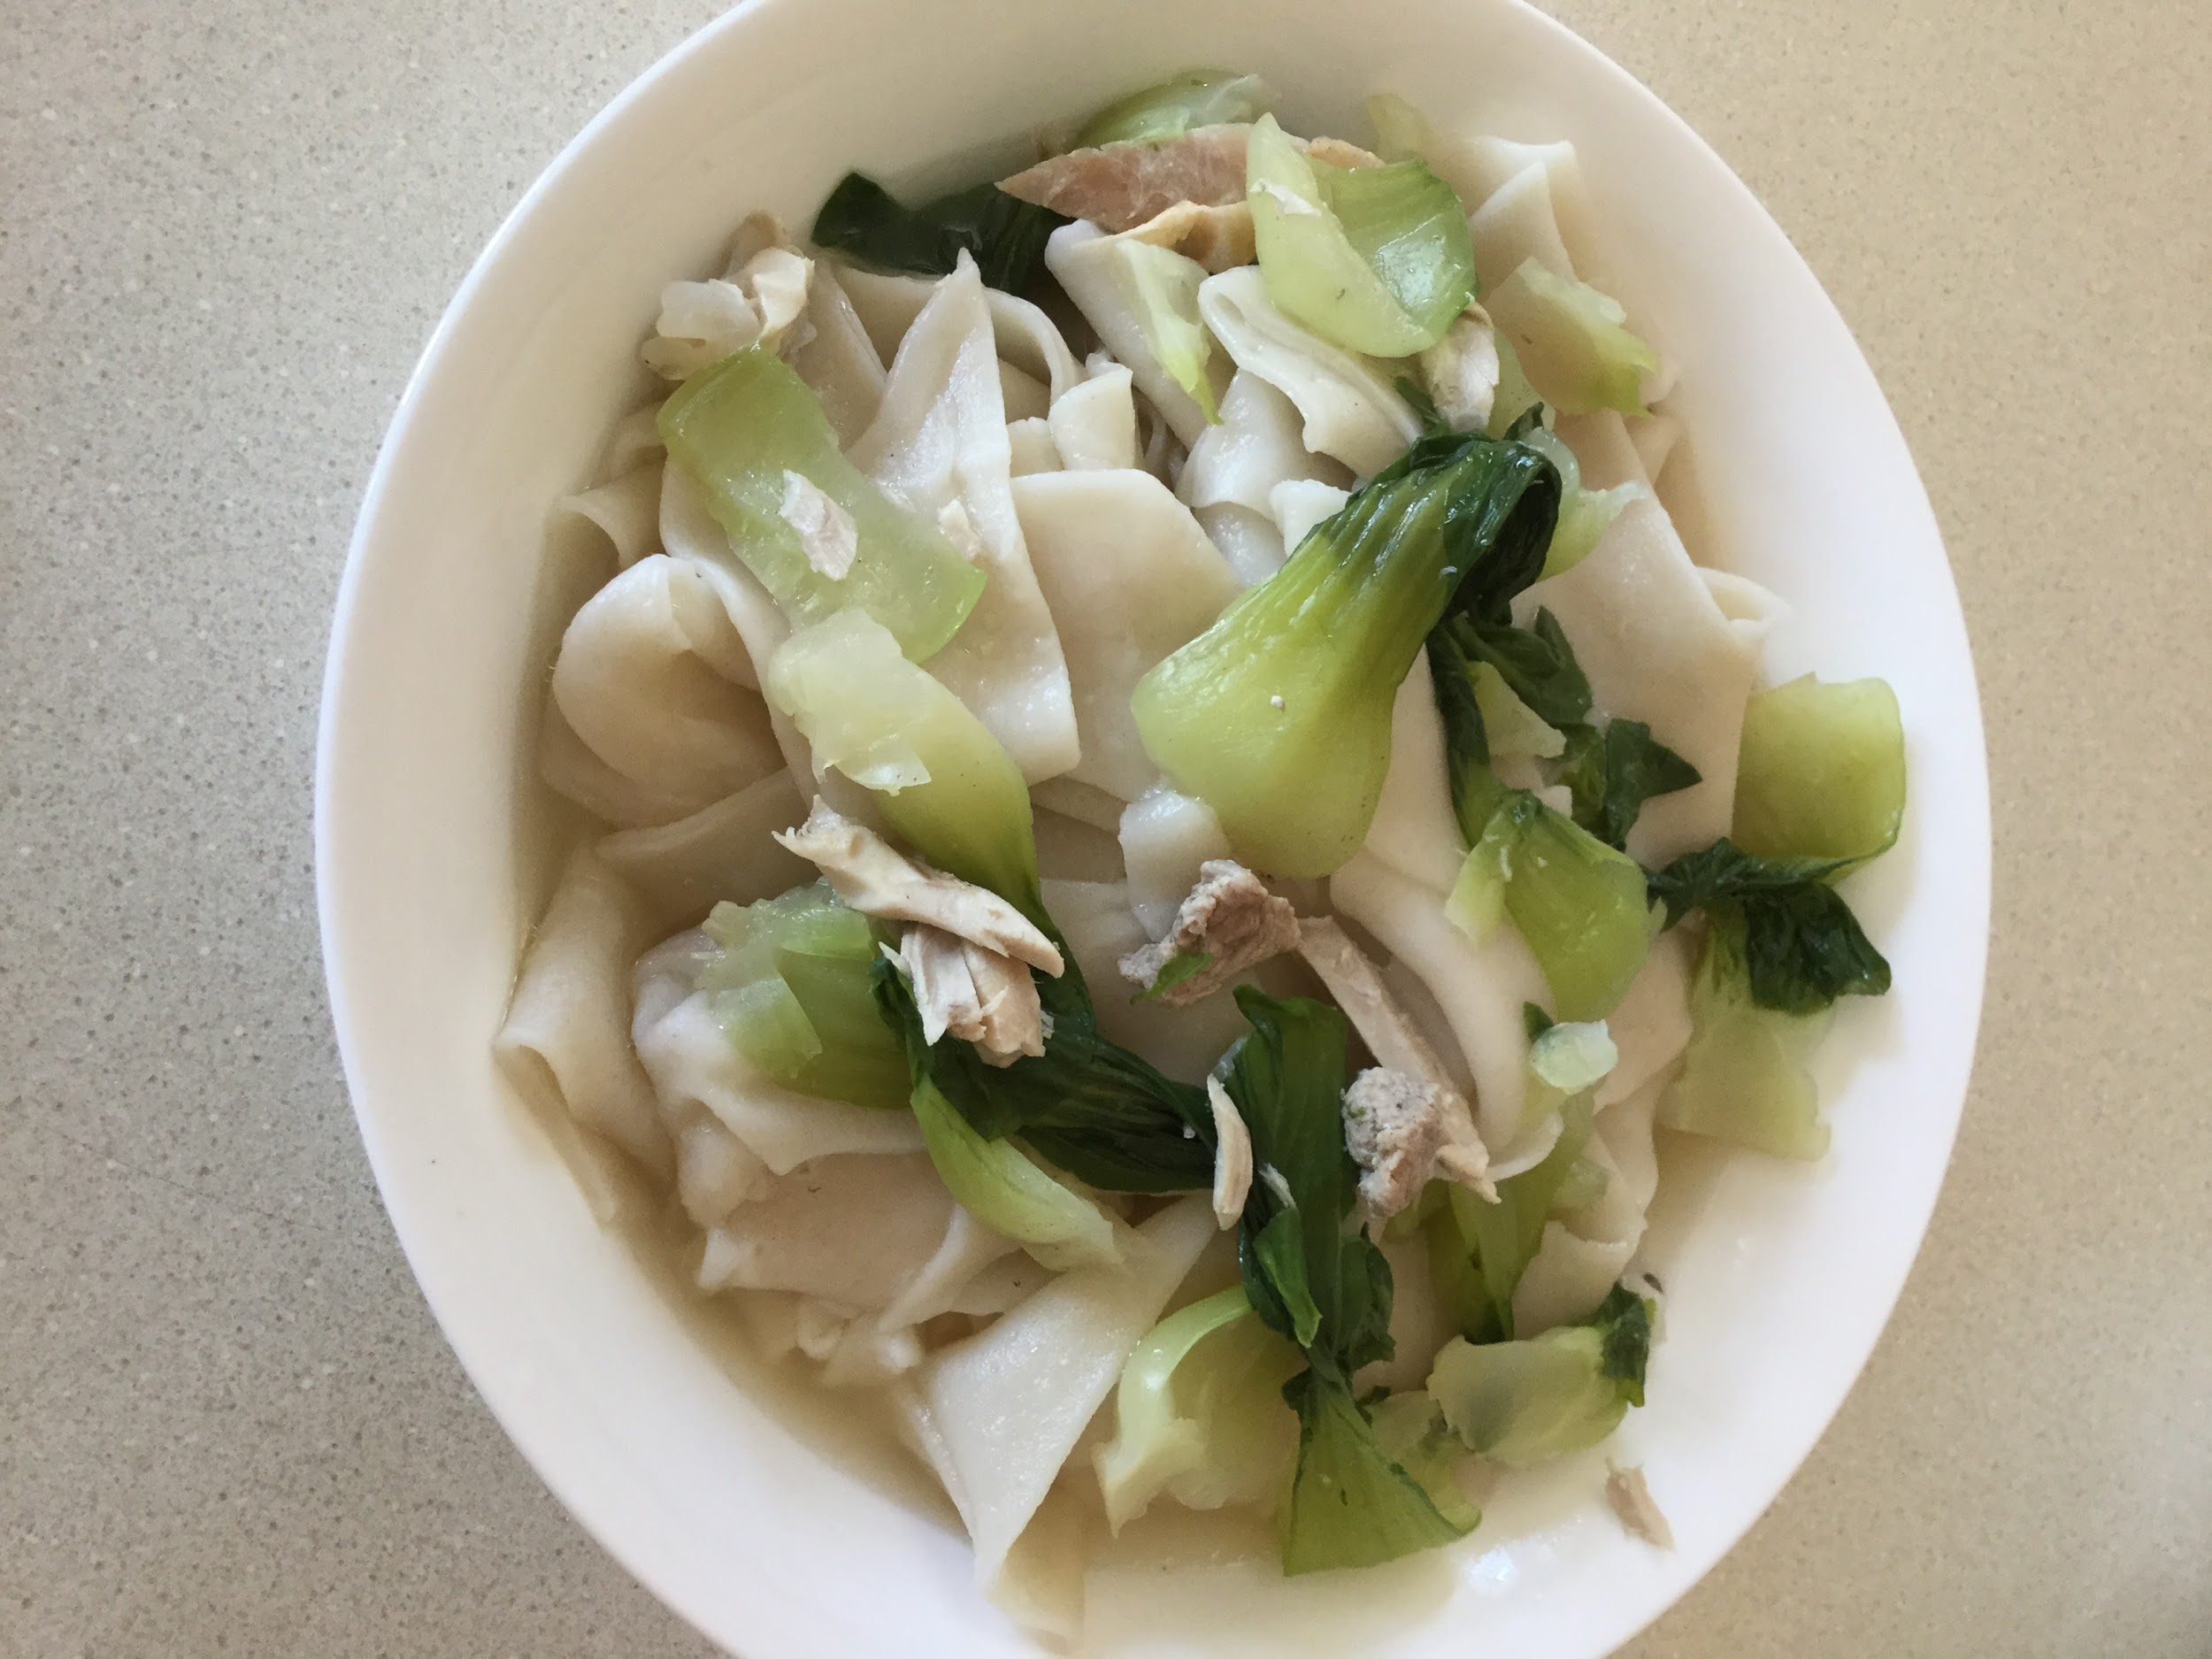
Easy Handmade Noodles
Ingredients needed:- 400 grams (2 2/3 cup) all-purpose flour, and extra to dust the working surface -½ tsp of salt
-1 cup 3 tbsp (280ml) of water (room temperature)
Instructions: To prepare the dough: 1. Combine flour and salt in a large bowl and mix well. Slowly blend in water and mix with a pair of chopsticks, until water is integrated with the flour and there is no dry flour left. Dust both hands with dry flour, then start to knead by hand until dough forms. The dough should be quite soft and sticky.
2. Dust a working surface with dry flour. Transfer the dough onto it and continue to knead until the surface turns smooth and the texture springy, 10 to 15 minutes. Dust hands and the working surface with extra flour whenever the dough starts to feel sticky during the process.
3. Alternatively you can use a stand mixer to make the dough. Attach the dough hook to the mixer, transfer the flour and the water into the bowl, and turn on low speed. Stop the mixer and scrape the flour from the bowl if needed. Mix until the dough becomes smooth and elastic, about 15 minutes.
4. Dust a large bowl with dry flour. Transfer the dough to that bowl and cover the dough with a damp dish towel. Cover the bowl with a lid (or plastic wrap). Let the dough rest at room temperature for at least 2 hours (or store the dough in the fridge if you're planning to use it the next day, after resting at room temperature).
5. Dust the working surface and both hands with flour. Transfer the dough onto the working surface and knead it a few times. Divide the dough into 2 equal pieces, then again to make 4 pieces total. Knead each piece of dough by hand to shape a ball.
6. Dust the working surface again. Take one piece of dough and press it into a round disc. Roll it with a rolling pin into a long and round sheet, about 0.2 inches thick. Roll out the rest of the dough pieces the same way. Use large bowls or plastic wrap to cover and seal the dough sheets, to keep them from drying out. Let rest for another 30 minutes to 1 hour.
To pull and cook noodles: 1. Right before making noodles, bring a medium sized pot of water to a roaring boil (very important).
2. Work on the dough sheets one by one. You should cover the rest of the dough with a damp dish towel or plastic wrap.
3. Slice the dough sheet into several strips, about 2 centimeters (0.8 inches) wide (or narrower if you want thinner noodles).
4. Pick up a strip of dough and start to pull it from one end to shape an evenly thick, long noodle, until it becomes quite thin and almost breaks apart. It’s fine if the noodle breaks into 2 to 3 shorter segments. Drop the noodle immediately into the boiling water.
5. Pull another 2 to 3 strips of dough and drop them into the boiling water. Cover the rest of the dough with a damp dish towel. Boil the noodles until cooked through,1 to 2 minutes.Transfer to a plate and set aside. Work on the rest of the dough in the same manner.
To serve and store: 1. You can use the noodles in any noodle soup or mix them with sauce. If you aren’t going to serve the noodles immediately, add a few drops of sesame oil onto them and mix by hand. You should always eat the noodles while they’re warm and fresh, because they will become sticky and turn into a solid mass once they cool off. Once noodles are finished, you can cook your veggies (bok choy) and meat. Once cooked, add onto the handmade noodles.
2. Store leftover noodles in an airtight container in the fridge for 1-2 days.
3. To serve leftover noodles, place them in a colander so that you can easily dip them into a pot of boiling water. When you do this, use a pair of chopsticks to gently separate the noodles, and leave them in the water until warm. Heating them this way shouldn’t take more than 30 seconds.
Family feedback: Noodles incorporated with meat and veggies nicely! Some pieces are thinner than others, which doesn't really matter. Somewhat bland.
Personal feedback: Next time, I would add some more salt than the recipe has recommended, perhaps adding a tiny bit of soy sauce for some more flavour.

