Due date: Monday May 28th, 2019 Name: ____________________________

BIOLOGY PRE-TEST

- Ribosomes are responsible for:

- Golgi body is responsible for:

- Cytoplasm is responsible for:

- Nucleolus is responsible for:

- Lysosome is responsible for:

- Cellular respiration is the process cells use to produce:

- Mitochondrion are to energy as vacuoles are to ____________________.
A. storage
B. osmosis
C. movement
D. reproduction

- Match each Term on the left with the best Descriptor on the right. Each Descriptor may be used as often as necessary.
Term | Descriptor
- centriole. ___________  - mitochondrion. ______  - ____________. ______  - ____________. ______  - ____________. ______ | A. consumption of sugar and oxygen to produce energy  B. functions in the division of animal cells  C. controls all functions of a cell  D. allows materials to flow into and out of a cell  E. carbon dioxide + water + light energy sugar + oxygen

- Which of the following is associated with converting light energy into stored energy?
I | nucleus
II | vacuole
III | chloroplast
IV | mitochondrion

- Which of the following is a structure found in plant cells but not animal cells?
A. cell wall
B. centriole
C. chromatin
D. cell membrane

- Where are chromosomes contained in a cell?
A. nucleus
B. ribosome
C. mitochondrion
D. cell membrane

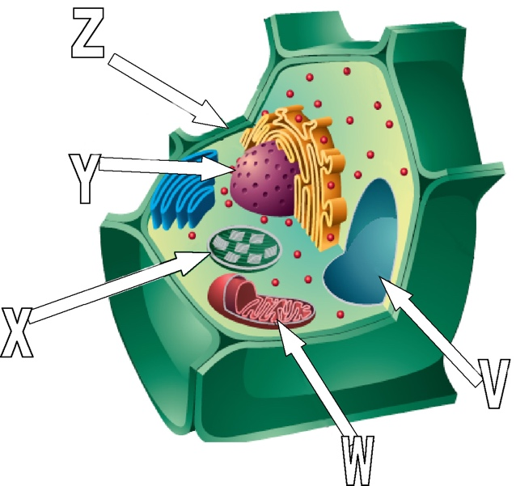

- Which structures provide support for the plant cell?
A. V and W
B. W and X
C. Y and Z
D. V and Z

- Identify every organelle on the diagram above, even those that are not labelled.

- What are three differences between a plant cell and an animal cell?

- One side of the DNA molecule has these bases: GATCCTACTCAT.
What is the other side of the DNA?
Rewrite the original in group of 3 (codon) before you make the sequence.

- All human cells have the same number of chromosomes which is _____.

- Draw a chromosome and show a gene.

- Your muscle cells and your skin cells contain identical DNA. How these cells able to function differently?

- a. Where are proteins made?
b. How does this organelle get the message of production?

c. Why are proteins, which are made from genes, so important? Give three examples of important things that protein does in the human cell.

- A Spirit bear is white. It is considered what type of mutation? neutral ? negative? Positive?

- Cystic fibrosis is considered a negative mutation. Why?

- Reorganise this DNA sequence in codons: GATACTCATTAG, Now, do the same with these 2 other DNA sequences and identify the problem: substitution, deletion or addition. * Look, there is plenty of space to rewrite codons below each sequence.

a) GATTCTCATTAG b) GATACTCATATAG c) GATACTCATTAGT

- Give 2 examples of chemical mutagens.

- Give 2 examples of radiation mutagen.

- Name any other type of mutagen.

- Draw one strand of DNA. Include 6 phosphate molecules (P), 6 sugar molecules (S), two adenine molecules (A), one guanine molecule (G). Complete the other side of the DNA strand with the matching base.

- Put the following terms in order and state one thing that happens at each stage of mitosis.

PHASE | WHAT HAPPENS?
1.
2.
3.
4.

Use the following diagram showing the stages of mitosis to answer the following 2 questions.

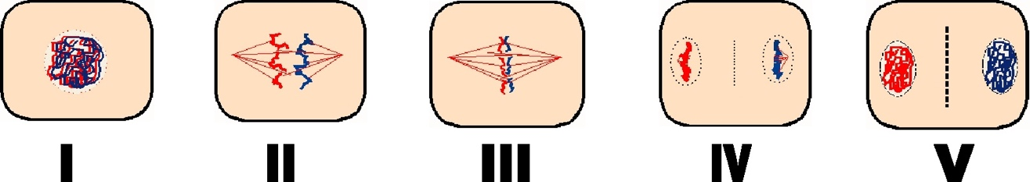

- Which two stages of mitosis are out of order in the diagram above?
A. I and II
B. II and III
C. III and IV
D. IV and V

- Which stage of mitosis is represented in diagram III?

- During which phase of mitosis are chromatids pulled apart and moved to opposite ends of the cell?

- In which stage of the cell cycle does replication of the DNA occur?
A. interphase
B. prophase
C. metaphase
D. anaphase

- Which of the following describes a human egg cell?
A. diploid zygote
B. haploid zygote
C. diploid gamete
D. haploid gamete

Use the following diagram to answer the following question.

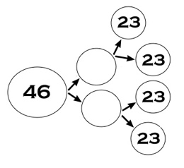
- The diagram shows the production of cells. Which of the following is illustrated in the diagram above? How do you know?
A. a leaf cell
B. a hair cell
C. a sperm cell
D. a muscle cell

- Which of the following describes fertilization?
A. Sperm cells are created in the testes.
B. Haploid cells combine to form a zygote.
C. Diploid cells combine to become haploid cells.
D. White blood cells reproduce to replace dead ones.

- Identify the meiosis phase. Make sure you write down if it is phase 1 or 2 or both.
- One “peanut” shape cell split in 2 new cells.
- Homologous chromosomes aligned in the middle of the cell.
- Chromatids are being pulled in opposite direction by the spindle fibers.
- Nucleolus and nucleus membrane are being formed.
- Nucleolus and nucleus membrane disappear, spindle fibers are attaching to the centromere. Homologous chromosomes are now visible.

- You see 2 cells in which the sister chromatids are aligned in the middle.

- When is the crossing over? Why is that important?
- A female gamete is called:
- A female gonad is called:
- A male gonad is called:
- A male gamete is called:
- In meiosis, only one female gamete survives, why?

- In meiosis, the cells are identical or unique?

- True or False.
T / F 1.There are two sets of chromosomes in humans.
T / F 2. For females the homologous pair of sex chromosomes is XY.
T / F 3. Mitosis continues with a second division of the cytoplasm.
T / F 4. In males the four sex cells become sperm.
T / F 5. Sexual Reproduction requires one parent.
T / F 6. Sexual Reproduction requires more time and energy to produce offspring.
T / F 7. Asexual reproduction produces a lot of variation.
T / F 8. Meiosis is responsible for growth, tissue repair and asexual reproduction.
T / F 9. Sexual reproduction produces offspring that are different from the parents.

- Fill in the blank.
  - Meiosis in the basis of ____________ reproduction.
  - Sexual reproduction requires ________ parents.
  - Females produce gametes called ____________ and Males produce gametes called _______________.
  - In humans, the body cell contains _______ chromosomes. Human body cells are ____________ (haploid / diploid).
  - A pair of matching chromosomes is called a pair of ______________ ________________.
  - The 23rd pair of chromosomes codes for sex. XX codes for _____________ (female / male) and XY codes for _____________ (female / male).
  - The products of meiosis are ____________ (haploid / diploid).
  - A human sperm cell has __________ chromosomes.
  - When an egg and a sperm join, __________________ takes place.

- Fill in the following table.

Organism | # Of chromosomes in body cell | Diploid number | Haploid number | Number of chromosomes in Meiosis I | Number of chromosomes in the sex cells.
Human |  |  |  |  | 23
Peanut | 20
Worm |  |  | 18

- a) A sperm cell of a grasshopper contains 12 chromosomes. How many chromosomes would a grasshopper body cell contain? (1 mark)

b) How many chromosomes would a diploid cell from the grasshopper have.

- Tell me what you can recognize about each karyotype.

- In pea plants, green pods (G) are dominant over yellow pods (g). Suppose a homozygous dominant plant is crossed with a heterozygous plant. What percent of the offspring will have green pods? Draw the Punnett Square to find your answer.

- Tall pea plants are dominant over short pea plants. A pea plant that is hybrid for plant height always shows the dominant trait. True or False

- Organisms in the F₂ generation are the parents of the F₁ generation. True or False

- If two possible traits are long tails and short tails, the characteristic for this trait could be “tail length.” True or False

Use the following description of a breeding experiment to answer the following 4 questions .

A snapdragon plant that is purebred for red flowers is crossed with one that is purebred for white flowers. In the F₁ generation, all the plants are pink. When plants from the F₁ generation are crossed, 400 plants are produced in the F₂ generation. In this F₂ generation, 103 are red, 198 are pink, and 99 are white.
For each question below:
Circle A if the statement is supported by the experiment.
Circle B if the statement is refuted by the experiment.
Circle C if the statement is neither supported nor refuted by the experiment.

- The red flower trait is dominant over the white flower trait. A B C

- Some plants in the F₂ generation are purebred for flower colour. A B C

- About 50% of the plants in the F₂ generation are heterozygous for flower colour.
A B C

- In the F₁ generation, 400 plants were produced. A B C

- Match each description on the left with the correct term on the right. Each term may be used as often as necessary. Record your answers on the lines provided.
Description | Term
- RR or rr _______  - rr _______  - organisms with matching alleles _______  - Rr _______  - organisms with matching dominant alleles _______  - organisms whose alleles are not the same _______ | A. heterozygous  B. homozygous  C. homozygous dominant  D. homozygous recessive

- A red plant crosses with a yellow plant and produces orange plants. This is an example of what type of dominance?

- Give an example of co-dominance.
- Match each description on the left with the correct term on the right. Each term may be used as often as necessary. Record your answers on the lines provided.
Description | Term
- hereditary unit of information passed on from parent to offspring ________  - genetic makeup of an organism ________  - the study of how inheritable traits are passed on from generation to generation ________  - description of a trait that might be present, but hidden in a generation ________  - the appearance of a particular characteristic in an organism ________  - one of the possible versions of a gene ________ | A. gene  B. allele  C. genetics  D. recessive  E. genotype  F. phenotype

- A purebred grey mouse was mated with a purebred white mouse. All the offspring were grey. Which of the following describes the allele for the colour grey?
A. recessive
B. dominant
C. codominant
D. incompletely dominant

- A purebred purple-flowering pea plant is crossed with a purebred white-flowering pea plant. Plants in the resulting F₁ generation all have purple flowers. If a plant from the F₁ generation is self-pollinated, what is the probable appearance of the F₂ generation?
A. 100% white
B. 25% white and 75% purple
C. 75% white and 25% purple
D. 100% purple

- A certain breed of mice is either brown or white. Consider the data below for a mating pair of mice.

Female mouse | homozygous | white
Male mouse | heterozygous | brown

a) Which trait is dominant, brown or white?

b) Select appropriate letters and write the genotype for the brown mouse and for the white mouse.
brown mouse _________
white mouse _________

c) Complete a Punnett square showing the cross between the brown mouse and the white mouse.

d) What is the phenotypic ratio expected between the brown offspring and the white offspring?

e) If a litter of 8 mice are born, how many of them are likely to be brown?

- Read the following information on sickle cell anemia and use it to answer questions (a) to (f).

A single mutation in a gene for hemoglobin causes a condition called sickle cell anemia. The normal allele is written as “H” and the sickle cell allele is “h.” Persons who are homozygous for the sickle trait have sickle cell anemia, which is a painful and deadly condition. People with it rarely live long enough to have children. However, persons who are heterozygous for the trait have a strong resistance to malaria. Malaria is a painful and often fatal disease common in central and western Africa.

a) A mother who is not a carrier for sickle cell anemia has children with a father who is a carrier but does not have the disease. What is the chance that their offspring will have sickle cell anemia?

b) Both the mother and the father are carriers but do not have the disease. What is the chance that their offspring will have sickle cell anemia?

c) The father has sickle cell anemia, but the mother is completely free of the sickle trait. What percentage of the offspring will have sickle cell anemia?

d) Offspring who have sickle cell anemia rarely have children because they die before reaching adulthood. Why does the trait not disappear from the population?

e) Suggest a reason why sickle cell anemia is present to a greater degree in Canadians of African descent than in Aboriginal Canadians?

f) Sickle cell anemia demonstrate which of Charles Darwin idea?

- My friends decided to abort when they found out their baby girl had Edwards Syndrome. A. What is the karyotype like?
B. What are the characteristics of a baby born with this syndrome?

- We see many people with Down Syndrome, why foetus with this syndrome survived while we don’t usually see a foetus with 3 chromosomes #4?

- Here are possible test you can do if you have a genetic disease story.
- Amnioscentesis : 1/200 women will have a miscarriage
- Chorionic villus sampling (CVS) : take cells from the placenta- 1/100 women will have a miscarriage, earlier test 10 weeks old
- Preimplantation genetic diagnosis: sperm+ egg in Petri dish, you can take the healthy embryo and implement it in the uterus at least $10 000
Do you foresee any ethical dilemma in testing? Why and why not?

- A. Do a spider web or other diagram of your choice to connect all the genetic diseases that were presented in class by Shannon and your classmates.

B. As specialist in genetics, your patients came to see you for your advices. The cells from the foetus gathered with an amnioscentesis is showing a disease. For which of the diseases presented in class would you present abortion as a possible option and why? Or why not? Chose 3 of them.

- Let’s Talk About GMOs And The Environment | Pros & Cons of GMOs | GMO Answers
https://www.youtube.com/watch?v=KonUXpTv0SI
- Watch this video and write the pros, there are no cons in it…

- Check this different resource: Vancouver Sun 2014. Video isn’t activated but article is good.
http://www.vancouversun.com/health/case+against+genetic+engineering+food+crops/9564797/story.html
Write pros and cons

- Are GMOs Good or Bad? Genetic Engineering & Our Food video
https://www.youtube.com/watch?v=7TmcXYp8xu4
Write pros and cons that haven’t been mentioned yet and any other interesting info.

- Find a different source and add any pros or cons that have not been mentioned yet. Write the source.

- Ethical question: Where do YOU stand when we are talking about GMO’s? Why? Use facts from your notes above.

