GLOBE-WE LEARNING GUIDE

Why reconciliation?
Understanding the ugly legacy of residential schools

https://www.theglobeandmail.com/life/globewe/we-day-unit-3/article36824295/

Below: Discussion guides for kids • Elementary
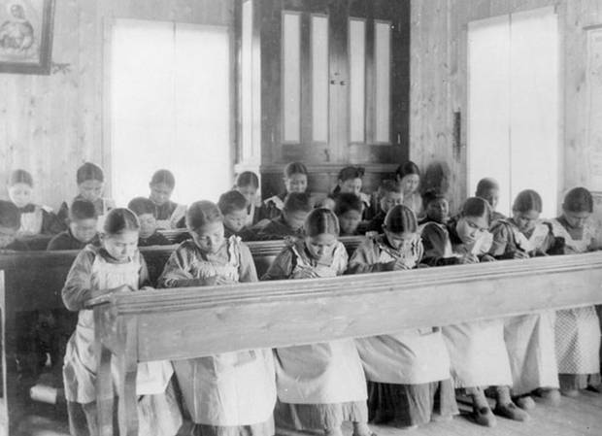
Students sit in a classroom at St Joseph’s Convent, also known as the Fort Resolution Indian Residential School in Fort Resolution, Northwest Territories, in an undated archive photo.
HANDOUT
CONTRIBUTED TO THE GLOBE AND MAIL
PUBLISHED NOVEMBER 6, 2017UPDATED NOVEMBER 6, 2017
PUBLISHED NOVEMBER 6, 2017
This article was published more than 2 years ago. Some information in it may no longer be current.

The Globe and Mail and We Charity have partnered to promote media literacy and education around global issues. This is part of a series of discussion guides and videos for parents and their children to read, watch and discuss together. Find more learning guides on the Globe-WE Learning Hub.
Indigenous people are the fastest growing population in Canada, and Justice Murray Sinclair, who sits on the Truth and Reconciliation Commission of Canada, believes it's important for Canadians to familiarize themselves with their story. "The first and most important step in establishing a good relationship is to be open to information about that person and be willing to share," he has said.
With that in mind, we need to go back to 1883, the year our federal government of Prime Minister Sir John A. Macdonald passed a law to officially establish a system of residential schools. One of Macdonald's ministers, Hector-Louis Langevin, is quoted as saying,"In order to educate the children properly we must separate them from their families. Some people may say that this is hard but if we want to civilize them we must do that."
More than 139 residential schools operated between the 1800s and 1996, when the last one was closed. More than 150,000 Indigenous children – First Nations, Inuit and Métis – attended these schools. Many of those were subjected to physical and sexual abuse, as well as harsh conditions. More than 6,000 children are estimated to have died in residential schools. An Indigenous child in a residential school had a higher risk of dying than a Canadian soldier during the Second World War.
Fast forward to 2015, when the Truth and Reconciliation Commission (TRC) released its final report on Canada's residential school system after years of travelling across the country, hearing testimony from thousands of survivors and fighting for the release of government documents.
"Removed from their families and home communities, seven generations of Aboriginal children were denied their identity through a systematic and concerted effort to extinguish their culture, language, and spirit," wrote TRC chair Justice Murray Sinclair in the report. "The schools were part of a larger effort by Canadian authorities to force Indigenous peoples to assimilate by the outlawing of sacred ceremonies and important traditions. It is clear that residential schools were a key component of a Canadian government policy of cultural genocide."
The legacy of the schools continues to this day with Indigenous people facing high rates of poverty, food insecurity, mental and physical health issues and death by suicide.
In an attempt to improve the lives of First Nations and Inuit people, the TRC report includes 94 recommendations and states: "The commission is convinced that a refusal to respect the rights and remedies in the declaration will serve to further aggravate the legacy of residential schools, and will constitute a barrier to progress towards reconciliation."
One of Prime Minister Justin Trudeau's election promises was to meet every TRC recommendation. In a statement released on National Aboriginal Day, he said: "No relationship is more important to Canada than the relationship with Indigenous peoples. Our Government is working together with Indigenous peoples to build a nation-to-nation, Inuit-Crown, government-to-government relationship – one based on respect, partnership, and recognition of rights." In 2016, Canada adopted the UN Declaration on the Rights of Indigenous Peoples.
Further reading:
- Truth and Reconciliation report calls for steps to improve First Nations’ lives
- Truth and Reconciliation Commission urges Canada to confront ‘cultural genocide’ of residential schools
- Truth and Reconciliation Commission timeline
- Truth and Reconciliation Commission final report: By the numbers

FAST FACTS: CANADA'S INDIGENOUS YOUTHS
Compared with the country's overall population (half of Canadians are at least 40 years old) the Indigenous community is youthful; half the population is younger than 24. Indigenous youth face greater challenges than non-Indigenous Canadians. Here are the four biggest:
Poverty
Indigenous children experience the highest rates of poverty in Canada. A report released in 2016 by the Canadian Centre for Policy Alternatives reveals that 51 per cent of Indigenous children live in poverty. That rate rises to 60 per cent if they live on reserve.
Education
A 2016 report from the C.D. Howe Institute reveals only four in 10 Indigenous youth living on reserve have graduated from high school, compared with nine out of 10 non-Indigenous young people. That's due in part to poor access to adequate and safe schools: in 2011, for example, 74 per cent of Indigenous schools required major repairs.
Suicide
Suicide and self-inflicted injuries are the leading cause of death among Indigenous youth. According to Health Canada, the suicide rate among Indigenous young people ages 15 to 24 is five to seven times higher than among non-Indigenous youth. An internal Health Canada memo from 2015 identified major gaps in care for children with mental health issues living on reserve. As a result, Indigenous young people often have to travel far from home for treatment.
Foster care
Almost half the children in Canada's foster care system are Indigenous. In 2016, the Canadian Human Rights Tribunal ruled that the federal government has discriminated against Indigenous children for years by allocating between 22- and 34-per-cent less money for welfare services than what is given to the provinces. Without social workers or proper services on reserves, more Indigenous children are removed from their homes than in other parts of the country.

SIZING UP THE WATER CRISIS IN FIRST NATIONS COMMUNITIES
While many of us take our access to water for granted, many First Nations communities do not have safe drinking water. On some reserves, the tap water is too contaminated even to wash dishes with. Drinking Water Advisories (DWAs), which are warnings against consuming or using water, are in place in 101 First Nations Communities (excluding B.C., where there were 20 DWAs as of August 31, 2017; and the Saskatoon Tribal Communities). The advisories are caused by anything from low water pressure to contamination, and reserves can have more than one advisory when they use more than one water system. Here's what else you need to know about the water crisis:
- 20,000: The estimated number of Indigenous people in Canada who do not have access to safe drinking water.
- 3 types of DWAs: boil water (meaning tap water is only safe to drink if it’s boiled for at least one minute); do not consume (bathing and washing are safe); and do not use (water isn’t safe for any use).
- 5 to 15: The number of years that water advisories have been in place in more than half of cases. There are 81 DWAs in Ontario, the most of any province or territory.
- 2/3: The proportion of First Nations communities that were under at least one water advisory between 2004 and 2014, according to a CBC investigation.
- 22: The number of years Neskantanga First Nation in northern Ontario has had a boil water advisory in place – since 1995. It’s the longest-standing boil water advisory in Canada. “For more than 20 years we haven’t been able to drink water from our taps or bathe without getting rashes,” said Neskantaga Chief Wayne Moonias. The federal government has committed nearly $9-million to upgrade the community’s water plant in order to lift the advisory by 2018.
- 2011: The year the United Nations Human Rights Council declared safe drinking water a human right. Canada recognized the declaration a year later.
- $1.8-billion: The amount of money in the federal government’s 2016 budget dedicated to improving water infrastructure on reserves. The goal is to end all DWAs within five years. However, the David Suzuki Foundation and the Council of Canadians investigated progress in nine First Nations communities in Ontario, which are all under long-term DWAs. Their report concluded that only three reserves are on track to meet the government’s timeline.

DISCUSSION GUIDE
For kids of elementary school age
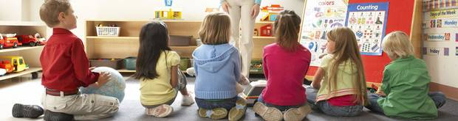
PHOTOS.COM
Reconciliation is a process of healing and restoring friendly relations – a process Canada is working toward between Indigenous and non-Indigenous Canadians. For more than 100 years, Indigenous children in Canada were required to attend government-funded residential schools, which removed them from their communities and the influence parents had in the spiritual, cultural and intellectual development of First Nations, Métis and Inuit children. The last residential school closed in 1996, but its legacy continues to affect Indigenous Peoples today. In Indigenous communities:
- 40 per cent of young people live in poverty.
- They are six times more likely to be killed than anyone else in the country.
- They make up 48 per cent of all children in foster care.
- 39.8 per cent have not completed their high school diploma.
- 1 in 4 report that their homes are in need of major repair.
- 32 per cent of schools have issues with access to clean drinking water.
- Six out of 10 people age 12 and older are diagnosed with at least one chronic illness.
Source: statcan.gc.ca, policyalternatives.ca
WATCH
PLAY VIDEO2:26

Key terms
- Aboriginal: inhabiting or existing in a land from the earliest time or from before the arrival of colonists.
- Allies: a state formally co-operating with another for a military or other purpose, typically by treaty.
- First Nations: people from one of Canada’s culturally diverse Indigenous groups who are not Métis or Inuit.
- Indigenous: originating or occurring naturally in a particular place.
- Reconciliation: the restoration of friendly relations.
- Treaties: a formally concluded and ratified agreement between countries.

Conversation starters
- Reconciliation is a process of mending broken relationships. What will your act of reconciliation be?
- How has the history of residential schools affected Indigenous Peoples in Canada?
- Whether you identify as Indigenous or non-Indigenous, what are some ways you can educate yourself and others about Indigenous histories and cultures?

Listen, then discuss
The story of Claire and her grandfather.
- How have Indigenous Peoples contributed to the development of Canada?
- What contributions did Indigenous Peoples make to colonial settlements?
- How have Indigenous languages contributed to the names of Canadian places?

Watch, then discuss
5:46
- What was Chanie’s experience in the residential school as shown in the video?
- What is the expression on the faces of the children and Chanie while in the residential school? What do these expressions reflect?
- What was Chanie’s life like prior to his experience in the residential school?
- Why is it a “secret path”?

